**The transition from youth to adult custody in the Northern Territory**

|  |  |
| --- | --- |
| **Document title** | The transition from youth to adult custody in the Northern Territory |
| **Contact details** | Criminal Justice Research and Statistics Unit  Department of the Attorney-General and Justice |
| **Author** | Joy Jose Mingi |
| **Approved by** | Gemma Lake |
| **Date approved** | 15 April 2021 |
| **TRM number** | 2020/2663/0002~0001 |

|  |  |  |  |
| --- | --- | --- | --- |
| Version | Date | Author | Changes made |
| Version 1.0 | 04 November 2020 | Joy Jose Mingi | 1st draft |
| Version 1.1 | 06 November 2020 | Joy Jose Mingi & Carolyn Whyte | Document revision based on comments from CJRSU Director, Carolyn Whyte |

Contents

Executive Summary 4

1. Introduction 5

2. Methods 7

2.1. Study population 7

2.2. Data 7

2.3. Analytical methods 8

2.4. Limitations of the study 8

3. Results 9

3.1. Descriptive statistics 9

3.2. Survival Analysis 12

4. Discussion 16

5. Conclusion 16

6. References 17

# Executive Summary

**Aims** – Our aim was to investigate the transition from youth to adult custody of young people who completed their last episode of youth detention. The primary objective of the analysis was to determine:

(1) What is the recidivism rate of the study cohort? That is, what proportion of the cohort was received in the adult prison and how long did members of the cohort take to enter the adult prison system?

(2) Is there a difference in the recidivism rates between groups in the cohort?

(3) What are the predictors of transition from youth detention to adult custody?

**Methods** – The population was made up of 353 young people aged 15 – 18 who completed their last episode of detention in the Northern Territory from 2015 – 2019. Participants were followed up from their date of last discharge up to September 2020. All participants had attained adulthood during the study period. We used survival analysis because the outcome of interest is the time from last discharge from youth detention until first adult prison reception and we have some censored data. A Cox proportional hazard model was used to estimate the relationship of potential risk factors to first adult prison reception.

**Results** – The estimated five-year recidivism rate is 61 per cent. That is, 61 per cent of those discharged from their last episode of youth detention were estimated to enter the adult prison system within five years. The median time between discharge from youth detention and reception into adult custody is three years and four months. There were significant differences between recidivism estimates when the cohort was grouped according to gender, Aboriginal status, age at first youth detention, and number of correctional episodes involving youth detention. Our analysis showed that the strongest predictors of recidivism are male gender and higher number of correctional episodes involving youth detention. Males were 4.2 times as likely to enter the adult prison system as females. Offenders with higher number of correctional episodes involving youth detention were 1.2 times as likely to enter the adult prison system as those with lower number.

**Conclusions –** Our result is consistent with previous studies which showed that male gender and higher number of correctional episodes involving youth detention are the strongest predictor of transition to adult criminal career. This study can be improved by investigating risk factors that were not readily available for this study, such as the presence of a childhood protection order, out of home placement, alcohol and drug abuse, family dysfunction, and other childhood variables.

# Introduction

Data from Australian Institute of Health and Welfare (AIHW, 2020) publication ‘Young people returning to sentenced youth justice supervision 2018 – 19’ showed that 59 per cent of Australians aged 10 – 17 who were under sentenced youth justice supervision (community based supervision or detention) at any time from 2000 - 01 to 2018 - 19 served only one sentence and did not return to sentenced supervision. Some young people however, returned to sentenced supervision numerous times. Twenty-seven per cent of those whose first supervised sentence was detention and 17 per cent of those whose first supervised sentence was community-based returned and received five or more supervised sentences. Unfortunately, data for Northern Territory (NT) is not included in this cohort as NT data is only available from 2012-13 (AIHW, 2020). Although we know that the majority of young people did not return to sentenced youth supervision, we have no official statistics on how many of them eventually entered the adult justice system.

While most young offenders eventually desist from delinquent behaviour (Farrington, 1986; Piquero et al., 2007), many continue their criminal behaviour into adulthood. Lynch et al. (2003) followed the criminal careers of 1,503 young offenders ages 10 – 17 years old who had been ordered to serve a supervised youth sentence in Queensland from 1994 – 95 over a seven-year period. The study found that 79 per cent of those youths had progressed to the adult corrections system and 49 per cent had at least one term of imprisonment. Chen et al. (2005) investigated the reoffending behaviour of a cohort of 5,476 youth aged 10 to 18 who appeared in New South Wales (NSW) Children’s Court for the first time in 1995 and followed their criminal history for at least eight years. Nearly 70 per cent of the cohort reappeared in court (children and adult court) within eight years. These results are fairly consistent with the result from the Blumstein et al. (1986) study in the United States which showed that between 30 and 60 per cent of juvenile delinquents, apprehended by police or brought before the children’s court, later came into contact with the adult criminal justice system.

Moffitt (1993) proposed that there are at least two distinct anti-social behaviour pathways: adolescence-limited, where youths start to engage in criminal behaviour in adolescence but also desist before adulthood, and life-course-persistent, where criminal behaviour start in childhood and persist into adulthood. This theory was later supported using evidence from a longitudinal male birth cohort study (Moffitt et al., 1996). The few studies that looked into predictors of entry into adult prison given prior youth detention generally support the life-course persistent model. Benda (2001) showed that the strongest predictor is prior incarcerations, followed by age the persons started committing crime. Piquero & Buka (2002) observed that juvenile chronic offending was the strongest and most consistent predictor of an adult crime status. Lynch et al. (2003) showed that the predictors of sustaining a criminal career into adulthood are gender, Aboriginal status, and the presence of a care and protection order. Rhoades et al. (2016) found evidence of gender differences in childhood risk factors of adult offending. They found evidence that family adversity, and specifically family violence among girls but not boys significantly predicted time to first adult arrest. For boys however, juvenile offending was the sole predictor of adult arrests.

At present there is a paucity of information on the criminal and corrections history of young offenders after their exit from youth justice system in Australia, especially in the NT. Hence, in this study we tracked the recidivism rates of young offenders who completed their last episode of youth detention in the NT from 2015 – 2019. In this study recidivism is defined as first reception to adult prison after last discharge from youth detention. The primary objective of the study was to determine:

1. What is the recidivism rate of the study cohort? That is, what proportion of the cohort were received in the adult prison and how long did members of the cohort take to enter adult prison system?
2. Is there a difference in the recidivism rates between groups in the cohort?
3. Which of the risk factors (gender, Aboriginal status, number of youth detentions, most serious offence committed as youth, and age at first youth detention) are the strongest predictors of adult prison reception given prior youth detention?

This information will help inform the development of evidence-based policies and interventions aimed at reducing the continuation of youth offending into adulthood.

# Methods

## Study population

The study population is a cohort of young people who completed their last episode of detention in NT youth detention centres from 01 January 2015 to 31 December 2019 who were aged 15 – 18 at the time of last discharge from youth detention and had a discharge reason of either ‘expiry of sentence’ or ‘transfer to community supervision’. Excluded from the cohort were young people transferred to adult prison when they turned 18, and those who were less than 18 years old on 01 January 2020. The last exclusion criteria was included to ensure that everyone in the cohort had attained adulthood during our study. The cohort selection is detailed in Figure 1.

Figure 1. Flowchart of cohort selection

Integrated Offender Management System (IOMS) database search for all offenders released from youth detention from 01 January 2015 to 31 December 2019.

544 youths aged 10 – 18 who completed their last youth detention identified

34 youths excluded: Transferred to adult custody

510 youths discharged from custody identified (Sentenced expired or transferred to community supervision

139 youths excluded: < 18years old on 01 Jan 2020

371 youths discharged from custody who are 18 years old and above on 01 Jan 2020

18 youths excluded: <15 years old on last discharge

353 youths included in the study cohort

## Data

The data used in this study was extracted from Integrated Offender Management System (IOMS). Discharge data was obtained for all offenders discharged from NT youth detention centres from 01 January 2015 to 31 December 2019. Adult prison reception data was extracted on 21 September 2020. Thus the follow-up period ranges from ten months (for the last youth released in November 2019) up to five years (for youths released in 2015). The cohort’s demographic data and corrections history were also extracted from IOMS.

## Analytical methods

The traditional recidivism calculation examines a cohort of individuals meeting specific criteria and then determines the percentage of those individuals experiencing the event of interest within some specified time frame, such as two years. Although simple to implement, this methodology is not adequate to answer our research questions. In addition, our follow-up time is not the same for everyone in the cohort, which results in some censored data. We used survival analysis because the outcome of interest is the time from last discharge from youth detention until first adult prison reception. It also considers a key analytical problem in our dataset called censoring – that is we have some information about the youth’s survival time (i.e. how long it has been since they were discharged), but we don’t know the full survival time because we stopped the study before all individuals were received into adult prison. The Kaplan-Meier estimator was used to measure our recidivism indicator, the proportion of the study group received in adult prison within a certain amount of time after discharge from youth detention. The log-rank test was used to compare the recidivism rates between groups of offenders. A Cox proportional hazards regression model (Cox, 1972) was used to investigate the association between youth characteristics and recidivism. We hypothesise that gender, Aboriginal status, number of correctional episodes involving youth detention, most serious offence committed as youth, and age at first youth detention are the predictors of recidivism.

## Limitations of the study

Childhood variables such as any childhood protection order, out of home placement, alcohol and drug abuse, and family dysfunction were not included in this study. Although potential predictors of youth offending and recidivism, these data are not readily available for this study.

# Results

## Descriptive statistics

The baseline characteristics of the youth offenders in the study population are summarized in Table 1. Note that these may differ from the characteristics of all youth detainees due to the selection process described above. Ninety-five per cent of the offenders in the study were Aboriginal, and 85 per cent were male. The median age at first youth detention is 15 while the median age at last youth discharge is 17. The median number of correctional episodes involving youth detention is two.

Table 1. Baseline characteristics of the youth offenders

|  |  |
| --- | --- |
| Youth characteristics | Result |
| Indigenous status |  |
| Non-Aboriginal | 16 (4.53%) |
| Aboriginal | 337 (95.47% |
| Gender |  |
| Female | 53 (15.01%) |
| Male | 300 (84.99%) |
| Median age at first youth detention | 15 (14 – 17) |
| Median age at last discharge from youth detention | 17 (16 – 17) |
| Median number of correctional episodes involving youth detention | 2 (1 – 3) |
| Total | 353 |

Although both genders have the same median age at first youth detention, Figure 2 shows that the shape of age distribution differs between genders. The curve for females is bell shaped with a peak corresponding to the median age of 15 while the curve for males is an increasing step chart with a peak at 17.

Figure 2. Distribution of youth offenders by gender and age at first youth detention

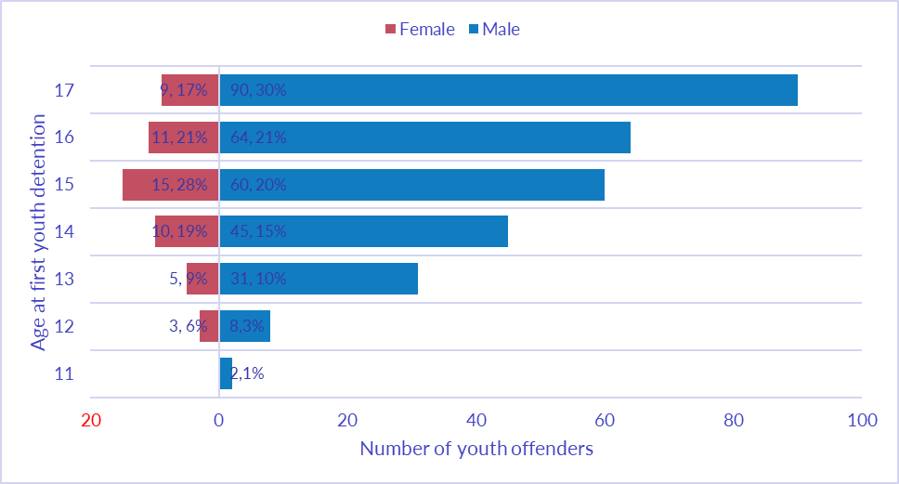We examined the youths’ entire correctional history and checked the most serious offence (MSO) for all correctional episodes involving youth detention. We are interested in the MSO at first correctional episode involving youth detention and in the most serious of all MSOs in the youth’s entire correctional history or the most serious offence committed as youth. For this study, we grouped the MSOs into three main categories:

1. Offences against the person (homicide, acts intended to cause injury, sexual assault and related offences, robbery, and abduction, harassment and other offences);
2. Property offences (commercial break-ins, house break-ins, theft and related offences, property damage, and arson);
3. Other offences (dangerous driving offences, offences against justice procedure, public order offences, illicit drug offences, prohibited and regulated weapons and explosive offences, and all other offences).

On their first correctional episode involving youth detention, the most common offence is offences against the person (39%) followed by property offences (38%), and all other offences (23%). Figure 3 shows that up to age 15, the majority of detainees on their ever youth detention were detained due to property offences. At age 16, the property offences dropped but the offence against the person kept on increasing. Other offences are lowest across all ages except at age 16 when this category overtook property offence due to increase in number of driving-related offences.

Figure 3. Category of offence at first youth detention

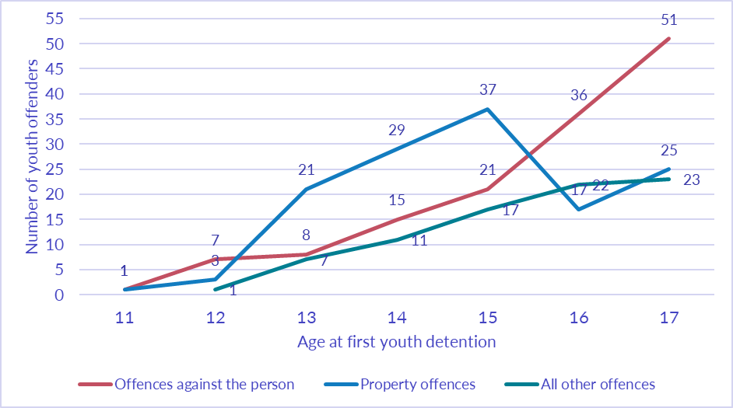

Most of the youths 150 (42%) had only one correctional episode involving youth detention and did not have further correctional episode involving youth detention. Some young people though, had multiple correctional episode involving youth detention and 54 (15%) youths had five or more episodes as shown in Figure 4. The most serious offence committed as youth are offences against the person (60.3%), followed by property offences (26.6%), and all other offences (13.0%).

Figure 4. Number of correctional episodes involving youth detention

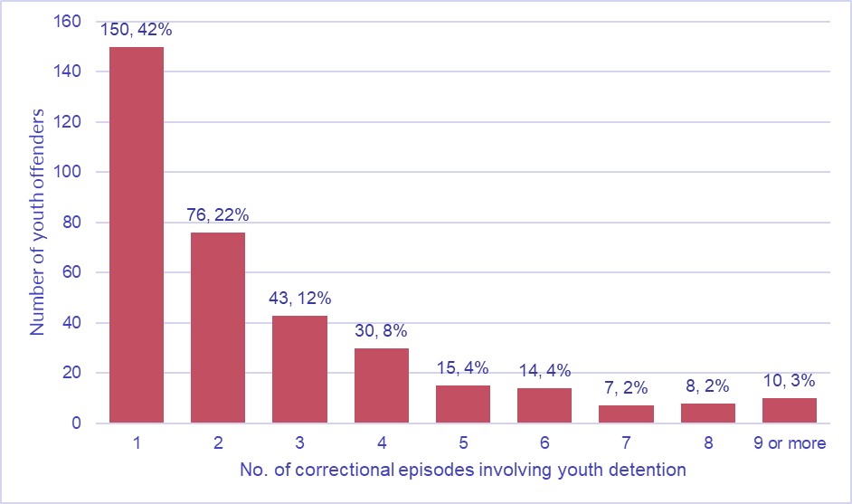

## Survival Analysis

The Kaplan-Meier recidivism estimate for all the young offenders in the cohort is shown in Figure 5. The recidivism estimate is 23.2% (95% confidence interval [CI] 19.2 – 28.0) after one year and 61.3% (CI 54.9 – 67.8) by five years after discharge. The median time between discharge from youth detention and reception into adult custody is three years and four months.

Figure 5. Proportion of youth detainees received in adult custody



The recidivism estimates by gender, Aboriginal status, age at first detention, number of correctional episode involving youth detention, and most serious offence committed as youth are shown in Figures 6 to 10. The log-rank test was used for comparing recidivism curves among two or more groups. There were significant differences between Kaplan-Meier recidivism estimates for males and females (p = 0.0000), Aboriginal and non-Aboriginal (p = 0.0474), age at first youth detention (p = 0.0005), and number of correctional episode involving youth detention (p = 0.0439). There were no significant differences in recidivism rates by most serious offence committed as youth (p = 0.0553). Note that these tests compare whether groups having specific characteristics had different recidivism rates; however, they do not represent the impact of those factors on recidivism, as the groups differed in other ways.

Figure 6. Proportion of youth detainees received in adult custody by gender



Figure 7. Proportion of youth detainees received in adult custody by Aboriginal status



Note that confidence bands are not included for figures 8 – 10 due to the degree of overlap.

Figure 8. Proportion of youth detainees received in adult custody by age at first youth detention



Figure 9. Proportion of youth detainees received in adult custody by number of correctional episodes involving youth detention



Figure 10. Proportion of youth detainees received in adult custody by most serious offence committed as youth



The Cox proportional hazard (PH) regression model was used to analyse the effect of the predictor variables or risk factors on recidivism. Testing of the PH assumption indicated that all variables except age at first detention (p-value = 0.0036) satisfy the PH assumption. Because one of the predictor variables does not satisfy the PH assumption, the stratified Cox procedure was used for analysis (Kleinbaum & Klein, 2005). Using stratified Cox, we can control for the variable which did not satisfy the PH assumption (age at first detention) by stratification while simultaneously including all the other variables which satisfy the PH assumption. The result of stratified Cox regression is summarized in Table 2.

Table 2. Cox proportional hazard regression model result

|  |  |  |
| --- | --- | --- |
| Risk Factors | Hazard Ratio (HR) (95% CI for HR) | p-value |
| Gender | 4.20 (2.21 - 8.00) | 0.000 |
| Aboriginal status | 2.16 (0.80 - 5.87) | 0.130 |
| Number of correctional episodes involving youth detention | 1.20 (1.09 - 1.32) | 0.000 |
| Most serious offence committed as youth | 1.22 ( 0.98 - 1.52) | 0.081 |

Male gender (p-value = 0.000) and number of correctional episodes involving youth detention (p-value = 0.000) are the significant predictor of recidivism or progressing to adult prison. Aboriginal status (p-value = 0.130) and most serious offence committed as youth (p-value = 0.081) are not significant.

# Discussion

The estimated five-year recidivism rate is 61 per cent. That is, 61 per cent of those discharged from youth detention are estimated to enter the adult prison system within five years. Recidivism estimates vary significantly according to risk factors such as gender, Aboriginal status, number of youth detentions, and age at first youth detention. Recidivism estimates are higher for males, Aboriginal youths, and youths with higher number of correctional episodes involving youth detention. Analysis by age at first detention shows that those who had their first detention at age 17 have the highest chance of being received in adult custody, followed by those who were 11-13 and 14 years old at their first detention. This is contrary to the expected result, which is that the youths who started their criminal careers younger have higher recidivism than those who started later. It should be noted however that we did not distinguish between those who were received to adult prison due to new offending or due to violation of discharge conditions. The high recidivism rate for those 17 years old during their first detention could be explained by the fact that most of them were released to some form of supervision when they turned 18. Twenty-two per cent of those 17 years old were received in adult prison due to violation of their youth detention discharge conditions.

Cox proportional hazard regression analysis showed that the main predictors of entry into adult prison given prior youth detention are male gender and higher number of youth detentions. This result is fairly consistent with the result from previous studies which showed that the strongest predictors of entry to adult prison system are prior incarcerations (Benda, 2001) and male gender (Lynch et al., 2003). Although Lynch et al., 2003 shows that Aboriginal status is a predictor of sustaining a criminal career into adulthood, our result indicates otherwise. This dissimilarity, however, can be explained by the fact that 95 per cent of our cohort are Aboriginal youths.

# Conclusion

Of those discharged from their last youth detention episode, 61 per cent were estimated to enter the adult prison system within five years. The median time between discharge from detention and reception into adult custody was three years and four months. Consistent with previous studies, our analysis showed that the strongest predictors of recidivism are male gender (hazard ratio = 4.2) and higher number of youth detentions (hazard ratio = 1.2). Males were 4.2 times as likely to enter the adult prison system as females. Offenders with higher number of correctional episodes involving youth detention were 1.2 times as likely to enter the adult prison system as those with lower number.

This study can be improved by investigating more risk factors such as presence of a childhood protection order, out of home placement, alcohol and drug abuse, family dysfunction, and other childhood variables. Including such data, as well as increasing the follow-up period, could improve our understanding of the issues involved for those who transition to adult prison and those who desist before adulthood. This would help in designing targeted interventions to discourage at-risk youths from continuing their criminal career into adulthood.

# References

Australian Institute of Health and Welfare. (2020). *Young people returning to sentenced youth justice supervision 2018–19*. Juvenile justice series no. 24. Cat. no. JUV 133. Canberra: AIHW.

Benda, B.B., Corwyn, R.F., Toombs, N.J. (2001). Recidivism among adolescent serious offenders: Prediction of entry into the correctional system for adults. *Criminal Justice and Behavior,* 28, 588–613.

Blumstein, A., Cohen, J., Roth, J.A. & Visher, C.A. (eds). (1986). *Criminal Careers and Career Criminals*, vol. 1, National Academy Press, Washington DC.

Chen, S., Matruglio, T., Weatherburn, D., & Hua, J. (2005). The transition from Juvenile to Adult Criminal Careers. In Crime and justice bulletin: contemporary issues in crime and justice; ISSN: 1030-1046; no. 86. 12 p.

Cox, D. R. 1972. “Regression Models and Life Tables (with Discussion).” *Journal of the Royal Statistical Society*, Series B 34:187—220.

Farrington, D. P. (1986). *Age and crime*. In: Tonry, M.; Morris, N., editors. Crime and Justice: An Annual Review of Research. Vol. 7. Chicago IL: University of Chicago Press; p. 189-250.

Kleinbaum, D. G. & Klein, M. (2005). *Survival Analysis: A Self-Learning Text*. 10.1007/0-387-29150-4.

Lynch, M., Buckman, J. & Krenske, L. (2003). Youth justice: criminal trajectories. *Trends & issues in crime and criminal justice* no. 265. Canberra: Australian Institute of Criminology. https://www.aic.gov.au/publications/tandi/tandi265

Moffitt, T. E. (1993). Adolescence-limited and life-course-persistent antisocial behavior: A developmental taxonomy. Psychological Review, 100(4), 674–701. [https://doi.org/10.1037/0033-295X.100.4.674](https://psycnet.apa.org/doi/10.1037/0033-295X.100.4.674)

Moffitt, T.E., Caspi, A., Dickson, N., Silva, P., Stanton, W. (1996). Childhood-onset versus adolescent-onset antisocial conduct problems in males: Natural history from ages 3 to 18 years. *Development and Psychopathology*, 8:399–424.

Piquero, A.R., Buka, S.L. (2002). Linking juvenile and adult patterns of criminal activity in the Providence cohort of the National Collaborative Perinatal Project. *Journal of Criminal Justice*, 30:259–272.

Piquero, A.R., Farrington, D.P., & Blumstein, A. (2007). *Key issues in criminal career research: New analyses of the Cambridge Study in Delinquent Development*. Cambridge, UK: Cambridge University Press; 2007.

Rhoades, K. A., Leve, L. D., Eddy, J. M., & Chamberlain, P. (2016). Predicting the transition from juvenile delinquency to adult criminality: Gender-specific influences in two high-risk samples. *Criminal behaviour and mental health: CBMH*, *26*(5), 336–351. <https://doi.org/10.1002/cbm.1957>