COMMIT Parole
  - An analysis of program effectiveness in assisting offender parole completion
Document title | COMMIT Parole
Contact details | Criminal Justice Research and Statistics Unit  Department of the Attorney-General and Justice
Author | Kylie Williams
Approved by | Gemma Lake
Date approved | 15 April 2021
TRM number | 2020/2663/0002~0002

Version | Date | Author | Changes made
1 | 24 August 2020 | Kylie Williams | Formatted document

Acronyms | Full form
COMMIT | Compliance Management or Incarceration in the Territory
HOPE | Hawaii Opportunity Probation with Enforcement
NTCS | Northern Territory Correctional Services
MSO | Most Serious Offence
IOMS | Integrated Offender Management System
ANZSOC | Australian and New Zealand Standard Offence Classification

Contents
Executive Summary 4
1. Introduction 5
2. Results 6
2.1. Factors influencing COMMIT parole revocation 6
2.1.1. Episode sequence 7
2.1.2. Age 7
2.1.3. Duration of parole 7
2.2. COMMIT vs. non-COMMIT parole revocation 7
3. Conclusion 13
4. References 14

Executive Summary
From to October 2017 to October 2019, 108 individuals began a COMMIT parole community supervision order. One of the primary aims of COMMIT parole is to assist high-risk offenders to successfully complete their parole order without being revoked, and subsequently spending a large portion of their original order in prison. Thus, the Criminal Justice Research and Statistics Unit undertook to analyse revocation data related to these 108 COMMIT parolees, up to June 2020. The analyses identify factors that have a significant impact on the likelihood of parole revocation for COMMIT parolees, and compares time to revocation for COMMIT parolees with that of a matched group of similar parolees who did not participate in the COMMIT program.

Younger COMMIT participants, and those with a more entrenched prior criminal history, were at significantly increased risk of having their parole revoked. After controlling for observable individual and criminal history factors, there was no significant difference in the likelihood of parole revocation between COMMIT and non-COMMIT participants. Likelihood of revocation with substantial new offending was almost identical between the COMMIT and non-COMMIT groups, at 11% and 10% respectively within one year of starting parole. For revocation due to conditional breaches, an estimated 35% of COMMIT parolees will have their parole revoked within one year, compared to 28% of non-COMMIT parolees, however this was also not a statistically significant difference.

This analysis is based on a small cohort of offenders who have thus far participated in the COMMIT program. Therefore, it is possible that the small sample size is an impediment finding potential positive impacts of the COMMIT program. However, if the current trajectory of results is maintained, the more likely outcome is that COMMIT parolees will actually have a significantly higher rate of revocation than non-COMMIT parolees, owing to a greater likelihood of revocation for breaching their parole conditions.

Introduction
Community corrections has become an increasingly common form of supervision within Australia over recent years, with the national community corrections population growing by 18.6% between 2014/15 and 2016/17 (Productivity Commission, 2018). Moreover, community corrections is increasingly being used for a more diverse range of offenses; including violent and sexual offenders (Bushnell, 2018). Despite an increasing reliance on community corrections, there have been few evidence-based options for managing these offenders, and as a result there is often a continued reliance traditional supervision methods (Hyatt and Barnes, 2014).

In September 2017, amendments to the Parole Act came into effect, allowing offenders released on parole to be subject to a high-intensity supervision program called COMMIT. The COMMIT program arose out of the desire of NTCS to look at implementing new strategies to achieve behavioural change in recidivist offenders. It was based on Hawaii's Opportunity Probation with Enforcement (HOPE) program implemented in 2004 by Judge Steven Alm, who observed that multiple supervision violations for which there were often no consequences eventually led to revocation and lengthy prison terms (Duriez et al, 2014). HOPE emphasises close monitoring, frequent drug testing, and swift, certain and fair sanctioning for each parole violation. According to the program logic, certain but non-severe graduated prison sanctions will achieve behavioural change by sending a consistent message to offenders about personal responsibility and consequences, since non-compliance with supervision conditions has an immediate negative, but proportionate, impact on their lives.

Evaluations of HOPE based on a randomised control trial reported favourable results. Compared to offenders on “probation as usual”, HOPE probationers were less likely to be arrested for a new crime, test positive for illegal drugs, miss appointments with their supervisory officer, or have their probation revoked (Hawken and Kleiman, 2009; Hawken et al, 2016). However, evaluations of subsequent supervision programs modelled on HOPE in other jurisdictions in the United States have failed to show any positive effects of HOPE over probation as usual (Lattimore et al, 2016; O’Connell et al, 2016). Criticisms of the HOPE include that it may only be effective for drug-involved offenders, is resource intensive (Duriez et al, 2014), and that it ignores the findings of reviews and analyses that have shown programs focusing on providing human services to offenders are more effective than deterrence-orientated interventions that tend to have weak, null or even iatrogenic effects on recidivism (Cullen et al, 2018).

Given these conflicting results, it is imperative to evaluate whether COMMIT is an effective offender management program in the Northern Territory. This report focuses on one particularly important aspect of this: whether COMMIT is more effective at assisting community based offenders to complete their parole order without being revoked than non-COMMIT supervision.

Results

Factors influencing COMMIT parole revocation
Exactly half of the 108 COMMIT participants from October 2017 to October 2019 had their parole revoked, with a median time to revocation of 428 days. Given the diversity of individuals on COMMIT parole, it is helpful to understand which elements of a participant’s demographic and criminal history influence the likelihood of being revoked. To examine this, a statistical technique called stepwise regression was used to build a model predicting parole revocation. The stepwise regression tests factors encompassing potentially important aspects of an individual’s characteristics (Table 1), and adds or removes these factors as appropriate to build the most parsimonious model predicting parole revocation.

Table 1: Demographic and criminological factors potentially important in predicting revocation likelihood.
Factor | Description
Aboriginal status | Whether the individual is Aboriginal (ATSI=1/0)
Male gender | Whether the individual is male (Male=1/0)
MSO drug | Whether the individual was on a parole order for an MSO involving illicit drugs (MSO drug=1/0)
MSO assault | Whether the individual was on a parole order for an MSO involving assault (MSO assault=1/0)
MSO homicide | Whether the individual was on a parole order for an MSO involving homicide (MSO homicide=1/0)
Episode sequence | The episode sequence number of an individual at the time they begin their parole order
Prior contravention | Whether the individual had contravened a previous community corrections order (Prior contravention=1/0)
Duration of parole | This was grouped into four categories, with category one being a parole order of less than 6 months, category 2 a parole order of between 6 months and 1 year, and category 3 being all parole orders longer than 1 year, except for offenders sentenced to life parole, who were category 4 (Duration parole=1,2,3,4)
Days custody | The number of days an individual had spent in custody prior to being released on parole
Urban corrections | Whether an individual had their parole order supervised at Casuarina, Palmerston, or Alice Springs community corrections office, or a rural/remote office (Urban Corrections=1/0)
Age | An individual’s age at the commencement of parole
High surveillance | Surveillance level at discharge of custodial episode for which parole was granted (Surveillance 1=high surveillance, 0=medium/low surveillance)

Of these 12 factors, stepwise regression determined there were three which had a significant role in determining likelihood of parole revocation, namely:

Episode sequence
Higher episode sequence number increased likelihood of revocation. For every 1 increase in episode sequence number, the likelihood of revocation increased by about 10%. This is not surprising, given that those with higher episode numbers typically have longer criminal histories; repeatedly cycling into/out of the criminal justice system.

Age
Older age decreased likelihood of revocation. Every year older than 19 (the youngest age of COMMIT parolees) decreased the likelihood of revocation by about 4%. Again, this is not surprising: the “age-crime curve” is a well-known phenomenon in criminology. Criminal behaviour increases throughout adolescence and early adulthood, and then begins to decrease over the life course moving forward.

Duration of parole
Individuals with a longer parole order tended to have a lower likelihood of revocation. This is probably largely to do with the fact that revocation, and indeed recidivism in general tends to be especially high during the first few months of being released from prison (e.g. see Figure 5, where the revocation curve for both COMMIT and non-COMMIT parolees is particularly steep for about the first 90 days). For people with short parole orders, most or all of their parole order may encompass this very high-risk period.

COMMIT vs. non-COMMIT parole revocation
Given the significant investment of resources involved in COMMIT parole, it is important to understand how well the program assists offenders to successfully complete their parole order, comparative to “normal”/non-COMMIT parole. Without conducting a randomised control experiment, it can be difficult to determine whether a group of individuals undergoing a “treatment” (in this case, participation in COMMIT parole), have a better or worse outcome than a group of “controls” (people on a non-COMMIT parole order). Differences in participant characteristics, as has already been demonstrated, can have a large impact on recidivism. Therefore, if the COMMIT parole group is different to the non-COMMIT group across these factors, differences in revocation rates may be driven by these individual characteristics rather than participation in the COMMIT program.

To construct a group of individuals who were as similar as possible to the COMMIT participants and would thus function as an appropriate control group, a three stage approach was utilised. First, all individuals who were released from custody over the period 2016 to 2020 (approximately the same time period as COMMIT) onto a non-COMMIT supervised parole order were identified from the IOMS system. This process identified a non-COMMIT group of 438 individuals, which were compared to the COMMIT group across the variables defined in Table 1. Given that COMMIT parole is selective about which offenders can participate in the program, it is unsurprising that the two groups differed in some potentially important aspects.

The COMMIT group had a higher proportion of people who had contravened a community supervision order in the past (COMMIT is targeted at offenders with a demonstrated history of difficulties complying with supervision), a higher proportion of people who were supervised through an urban community corrections office (due to the difficulties of resourcing the program in remote communities, COMMIT parole is largely targeted at urban offenders), a higher proportion of people on parole for an MSO relating to illicit drugs (drug and alcohol testing and rehabilitation are a key focus of the COMMIT program), and a lower proportion of people with an MSO of assault (Figure 1).

Figure 1: Comparison of COMMIT vs non-COMMIT group characteristics (binary (1/0) format)
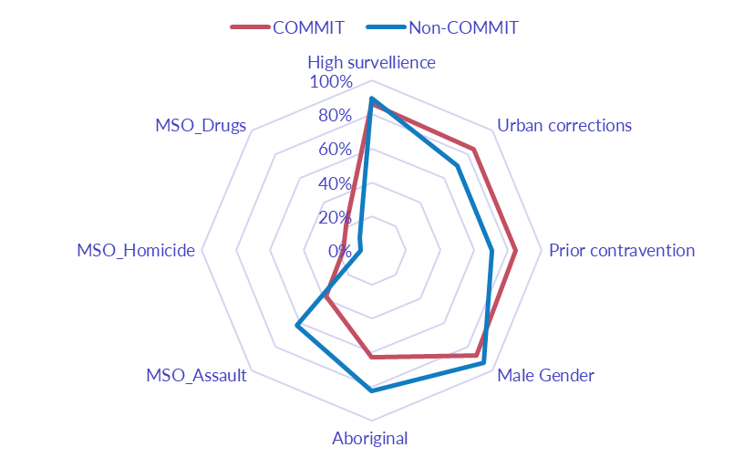

The proportion of Aboriginal people was noticeably lower in the COMMIT group, and is likely a consequence of COMMIT mostly not being available in remote communities, and an emphasis on individuals involved in drug offences rather than assault offences. Northern Territory adult prisoner statistics consistently reveal that illicit drug offences are MSO for about 30% of the non-Aboriginal prisoner population, compared to just 2% of the Aboriginal prisoner population. In contrast, assault is the MSO for over 50% of the Aboriginal prisoner population, compared to about 15% of the non-Aboriginal prisoner population.

Surprisingly, COMMIT participants had a lower average episode sequence – higher episode sequence number is generally a good predictor of greater likelihood of recidivism (Figure 2). The relative lower average episode sequence number is at least partly due to the higher proportion of COMMIT participants with an MSO of homicide, with these individuals typically having had one long corrections episode (as also indicated by the higher average days in custody for the COMMIT participants). Finally, the COMMIT group had, on average, a longer parole order duration. Again, this is a function of the program’s participant selection, with offenders having a parole order of one year or greater being the primary target offenders.

Figure 2: Comparison of COMMIT vs non-COMMIT group characteristics measured in continuous format. Age has been divided by a factor of 10 and Days custody by a factor of 100 for consistent scale.
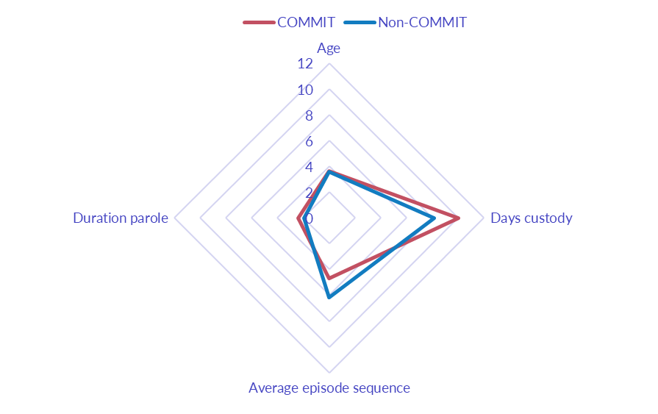

Given these differences between the COMMIT group and the broader parolee population, the second step in constructing an appropriate control group was a statistical technique called propensity score matching. A propensity score (number representing the overall likelihood of being in the COMMIT program based on variables in Table 1) was calculated for all individuals in both the COMMIT and non-COMMIT groups. 108 of the 438 non-COMMIT parolees were matched with the 108 COMMIT parolees, based on closest propensity score. This resulted in 108 COMMIT/non-COMMIT matched pairs. Exploratory analysis revealed that this process had eliminated or substantially reduced differences between the COMMIT and non-COMMIT groups (Figure 3, Figure 4).

Figure 3: Comparison of COMMIT vs non-COMMIT group characteristics measured in binary (1/0) format, after propensity score matching.

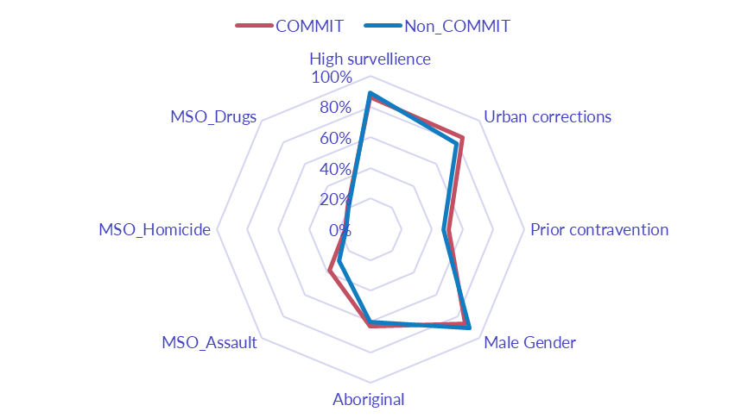

Figure 4: Comparison of COMMIT vs non-COMMIT group characteristics measured in continuous format, after propensity score matching. Age has been divided by a factor of 10 and Days custody by a factor of 100 for consistent scale.

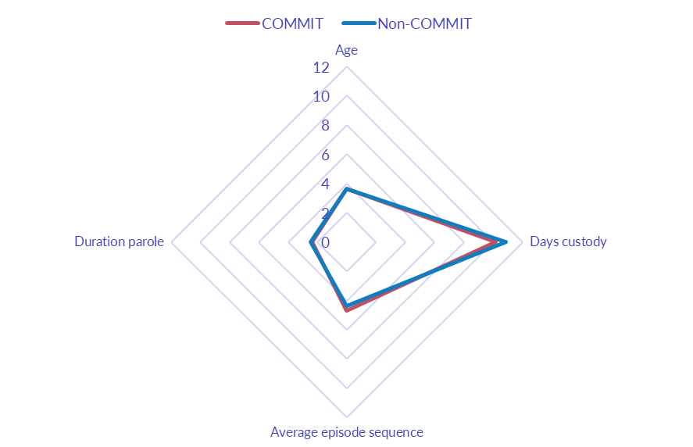

The third step was covariate adjustment using the propensity score to account for any remaining differences between the COMMIT and non-COMMIT groups via a stratified Cox model. In the stratified Cox model, each matched pair of COMMIT/non-COMMIT individuals forms a stratum, and estimates are then pooled across each of the 108 strata to calculate overall revocation likelihoods for the COMMIT vs. non-COMMIT groups. The output of this model (COMMIT participation: p=0.51, Hazard Ratio=1.19) indicated that after controlling for any remaining differences in individual characteristics, there was no difference in the likelihood of revocation between the COMMIT and non-COMMIT groups.

To help visualise these results a Kaplan-Meier curve was plotted to compare the COMMIT group with the matched individuals in the non-COMMIT group (Figure 5). This reinforced the findings of the stratified Cox model, with no significant difference between the COMMIT and non-COMMIT groups. After one year on parole, it is estimated that 44% of individuals in COMMIT parole will have been revoked. For the matched non-COMMIT group, this figure was 39%. While the curves do appear to diverge thereafter, this must be interpreted in light of the large confidence intervals at greater than one year, which mean that the estimates provided by the model are less robust due to the small number of individuals remaining in the sample. The substantial overlap of the confidence intervals between the two curves indicates that there is no significant difference between likelihood of revocation for COMMIT vs. non-COMMIT parolees across the entire follow-up period.

Figure 5: Revocation of COMMIT vs. matched non-COMMIT parolees groups by time since starting parole order.
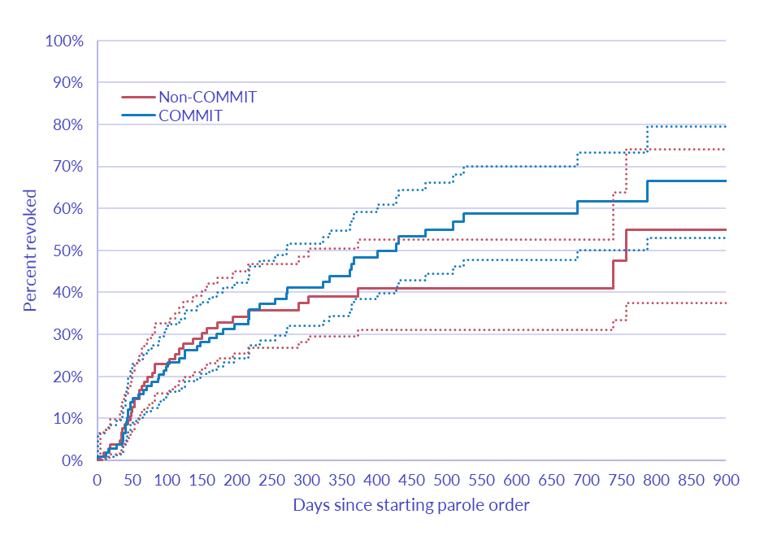
While parole revocation provides a useful estimate of the proportion of individuals who return to prison for a substantial period of time, it collapses all types of violations; from relatively minor technical violations such as failed drug tests and absconding, to serious and violent offending while on parole, into one outcome. Thus, competing risks models were developed in which parole revocation for either substantial new offending (i.e. excluding ANZSOC division 15 offences which deal with offences against government procedures), or parole revocation for violations of supervision conditions were defined as the primary events of interest. This revealed that an estimated 11% of COMMIT participants and 10% of non-COMMIT participants will have their parole revoked with substantial new offending within a year (Figure 6). Indeed, 12 COMMIT and 11 non-COMMIT parolees were revoked with new offending in the study.

In contrast, an estimated 35% of COMMIT parolees will have their parole revoked for breaches of supervision conditions within one year, compared to 28% of non-COMMIT parolees (Figure 7). However, particularly due to the small sample sizes, this difference was still not statistically significant. A higher rate of parole breaches is typical for intensive supervision programs more broadly. For example, Petersilia and Turner (1993) evaluated the performance of intensive supervision programs across 14 jurisdictions in the United States, finding that it did not decrease the frequency or seriousness of arrests for new offending, but did increase the incidence of technical violations and jail terms.

Figure 6: Revocation with new offending of COMMIT vs. matched non-COMMIT parolees groups by time since starting parole order.
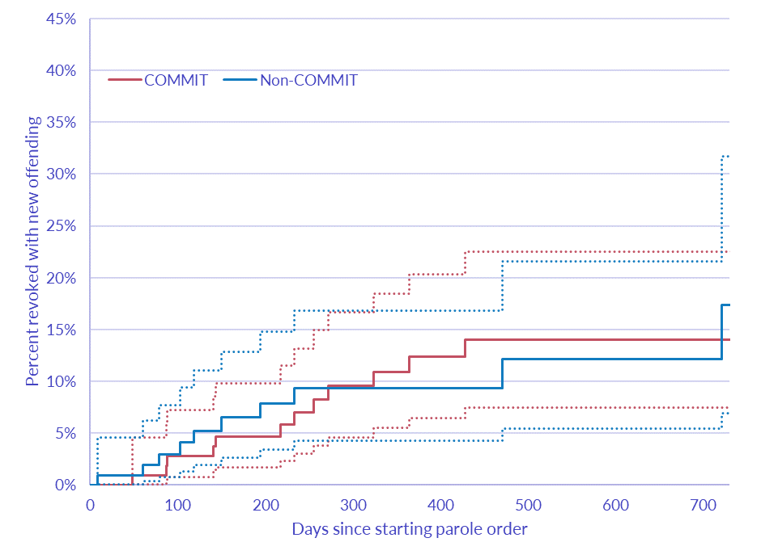
Figure 7: Revocation for breaching parole conditions of COMMIT vs. matched non-COMMIT parolees groups by time since starting parole order.
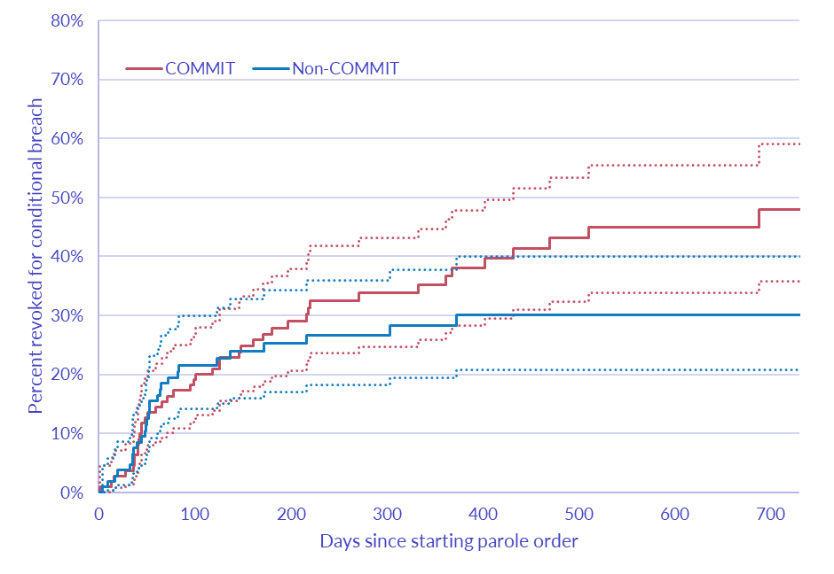

Conclusion
Likelihood of parole revocation arises from a complex interaction between what a parolee does, who a parolee is, and institutional orientations towards these factors (Grattet and Lin, 2016). Amongst COMMIT participants, younger age and higher episode sequence number increase likelihood of revocation. However, given that COMMIT is targeted at high risk offenders with significant prior exposure to the criminal justice system, modifying participant selection to exclude such individuals would be inconsistent with the program goals and principles of the Risk-Needs-Responsivity model, which proposes intensive supervision and services be reserved for higher risk offenders (Duriez et al, 2014).

At present, it does not appear that the COMMIT program is more successful than non-COMMIT at assisting offenders to successfully complete their parole orders without being revoked and returning to custody. For this to occur, the likelihood of COMMIT parolees being revoked for conditional breaches would need to be substantially reduced. Further research is required to determine the cause of revocations due to conditional breaches among COMMIT participants, and appropriate policy responses developed on this basis. It is possible that if COMMIT participants are subject to more intense monitoring, for example in the form of more frequent drug testing, then their frequency of breaches is simple a consequence of this. However, it is also possible that COMMIT participants have a higher frequency and/or seriousness of breaches under a similar intensity of supervision to non-COMMIT parole, or that authorities are responding more harshly to breaches by COMMIT parolees.

References
Bushnell, A. (2018). Making Community Corrections Work. Institute of Public Affairs.
Cullen, F., Pratt, T., Turanovic, J. and Butler, L. (2018). When bad news arrives: project HOPE in a post-factual world. Journal of Contemporary Criminal Justice, 34, 13-34.
Duriez, S., Cullen, F. and Manchak, S. (2014). Is project hope creating a false sense of hope: a case study in correctional popularity? Federal Probation, 78, 57-70.
Grattet, R. and Lin, J. (2016). Supervision intensity and parole outcomes: a competing risks approach to criminal and technical parole violations. Justice Quarterly, 33, 565-583.
Hawken, A. and Kleiman, M. (2009). Managing drug involved probationers with swift and certain sanctions: Evaluating Hawaii’s HOPE. National Institute of Justice, Washington DC.
Hawken, A., Kulick, J., Smith, K., Zhang, Y, Jarman, S. and Vial, T. (2016). HOPE II: A follow-up to Hawaii’s HOPE evaluation. National Institute of Justice, Washington DC.
Hyatt, J. and Barnes, G. (2014). An experimental evaluation of the impact of intensive supervision on the recidivism of high-risk probationers. Crime and Delinquency, 63, 3-38.
Lattimore, P., MacKenzie, D., Zajac, G., Dawes, D., Arsenault, E. and Tueller, S. (2016). Outcome findings from the HOPE demonstration field experiment. Criminology and Public Policy, 15, 1103-1118.
Petersilia, J. and Turner, S. (1993). Intensive probation and parole. Crime and Justice, 17, 28-335.
O’Connell, D., Brent, J. and Visher, C. (2016). Decide your time: a randomized trial of drug testing and graduated sanctions programs for probationers. Criminology and Public Policy, 15, 1073-1102.
Productivity Commission. (2018). Report on Government Services 2018 Vol. C.

