Reasons for Decision
Application by Darwin City Council for a Public Restricted Area
for Bicentennial Park and, the Rapid Creek and Nightcliff Foreshores
Applicant: Darwin City Council
Date of Decision: 2 April 2008
Legislation: Part V111 Divisions 1B, and 2 of the Liquor Act
Members: Mr Richard O’Sullivan (Chairman)
Ms Merran Short
Mr Wally Grimshaw
Appearances: Mr John Banks, Darwin City Council
Ms Jane Aagaard MLA, Residents of Nightcliff

Application for Public Restricted Area
- This is an application by the Darwin City Council for declaration of Public Restricted Areas pursuant to Section 76 of the Liquor Act (“the Act”).
- The application was originally made on 6 March 2007 by Mr Allan McGill, Chief Executive Officer of the Darwin City Council (“DCC”), seeking to have Bicentennial Park, the Rapid Creek Foreshore and an area of Coconut Grove extending to Pavonia Place declared a Public Restricted Area. This application was advertised and several submissions were received by the Licensing Commission (“the Commission”).
- Based on comments received and community input into the application, the DCC then made a further application on 8 November 2007 for an enlarged area to become a Public Restricted Area pursuant to Section 76 of the Act, including the Casuarina Coastal Reserve and areas of the Nightcliff Foreshores extending from Bougainvillea Street to Aralia Street (“the Application”).
- The required notices regarding the Application were posted and submissions from the public and interested parties were received by the Commission in relation to the Application.
- The response to advertisements advising the public of the Application included written responses supportive of the Application (none relating to Bicentennial Park) and a petition.
- There were two (2) Community consultation meetings on 18 February 2008. The first was at 10.00 hours at the DCC Chambers regarding Bicentennial Park. This meeting was attended by the Commission, the Town Clerk, the Mayor and several aldermen. No members of the public attended at this meeting despite the fact that it was advertised as being open to the public. The focus of the meeting was to discuss aspects and problems such as displacement which could arise if the Application was granted. Opportunity was also given to the Alderman present to ask questions of the Commission and discussion amongst members of Council regarding the details of the Application.
- The second public meeting was also on 18 February at 18.00 hours at the Nightcliff Community Centre, Nightcliff. This meeting was attended by the local member Jane Aagaard MLA, who was a driving force behind the Application, Mr John Banks on behalf of the DCC, some aldermen of DCC, business owners and members of the public. An opportunity was given to attendees to make submissions regarding the Application, ask questions of the DCC or the Commission. Statements were made to the Commission outlining in graphic detail some of the problems experienced by residents of the Nightcliff area, in particular, residents near or business owners in, Pavonia Place. Detail was also provided by Jane Aagaard MLA as to the feedback she had obtained from her constituents as well as the steps taken to facilitate the Nightcliff Shops, (Dick Ward Drive) including car park, becoming “dry” under Section 101C of the Liquor Act – Application for private premises to be declared restricted (or “dry). Reference was also made to the apparent success of the Commission decision to declare the Kulaluk Community at Lot 8030 (Town of Nightcliff) a General Restricted Area.
- A hearing regarding the Application was held on Friday 22 February 2008 (“the Hearing”) at 9.30 hours at the Commission Hearing room, Enterprise House, Corner Knuckey and Wood Streets, Darwin. The Hearing was advertised and open to the public. The Hearing afforded a further opportunity for members of the public to make submissions either in favour or against the Application. Matters rose at Hearing largely related to Nightcliff/Rapid Creek/Coconut Grove areas of the Application.
- On the day of the Hearing the Commission received a further submission from Commander Kendrick on behalf of the Northern Territory Police. The substance of the further Police submission was that if the Application was granted it would mean that the Police would be imposing different laws over different areas of Darwin. The first being the 2km law under the Summary Offences Act and the second, laws provided under the Liquor Act. There are substantial differences in penalty provisions under each Act and Commander Kendrick submitted that this in turn would make policing more difficult for Police members.
- As stated above, the Commission was presented with a petition and a number of written submissions. Written submissions were received from:
- Northern Territory Police,
- The DCC,
- Ms Jane Aagaard MLA, Member for Nightcliff,
- Local business owners, and
- Local residents.
In total there were eight (8) written submissions from local residents or business owners, a petition signed by fifty-one (51) residents or business owners, submissions from Police, DCC, and Jane Aagaard MLA, all in favour of the Application.
The Commission did not receive any objections to the Application either via written submission or at Hearing.
- At the Hearing oral evidence was given by a number of witnesses including:
- Mr John Banks – DCC,
- Commander Robert Kendrick – Northern Territory Police, and
- Ms Jane Aagaard MLA;

Submissions at Hearing

Darwin City Council
- Mr Banks outlined the reasons for the Application on behalf of the DCC. The primary reasons were cited as the extraordinary level of anti-social behaviour that the residents and business owners were experiencing due to the excessive drinking and abuse of alcohol that occurred in the areas the subject of the Application. Some of the examples given in the submissions in support of the Application regarded the Pavonia Place Area and included:
- Cancelled appointments for local business owners due to customers being “deterred from entering the area due to antisocial behaviour, drunks and humbugging”.
- Health issues arising from intoxicated itinerants using water bubblers and play equipment as toilets.
- Witnessing of “physical assaults with knives, sticks and broken bottles, sexual assaults, brawling, indecent exposure, prostitution, begging, harassing, ‘chroming’, vandalism and regular use of bad language.
- Business owners being too afraid to leave their premises at night without a Police presence.
- Itinerants urinating around the place, littering and leaving the common areas of the Nightcliff shops in a dirty, unwelcoming, messy and smelly state which is a real eyesore.
- Itinerants using business premises as sleeping areas blocking doorways and refusing to move and generally causing grief to traders and workers in the area.
Regarding the Foreshores:
- Loud and abusive swearing and fighting in areas used by the public including the areas frequented by families on a regular basis especially on weekends.
- Significant antisocial behaviour which was distressing to people using the bike/walk path and recreational areas.

Northern Territory Police
- For all the areas the subject of the Application it was a concern of the public and the Police that the ‘tip-out’ laws associated with the 2km law, which the area is currently subject to, has little or no effect. There was evidence before the Commission that even if liquor was tipped out and the itinerants forced to move on, as soon as the Police left they would be back and accessing liquor they had stashed for just such a circumstance.
- There seems little doubt that the ‘ineffectiveness’ of the 2km law in dealing with the known problems arising from excessive consumption of liquor in public is well recognised by the Police and causes them much frustration. During the Hearing Commander Kendrick, submitted that the enforcement of the Public Restricted Area would achieve more than the “2km law” (ie breach of Section 45D of the Summary Offences Act) which is currently in place. However, Commander Kendrick submitted to the Commission, and this was also set out in the further Police submission to the Commission, that the Application if approved “would no doubt have a positive impact on those particular areas, but will logically result in the displacement of those itinerants, and others who would normally drink there, and shift the problem to another place or places outside those declared areas, but still within public/residential precincts. These drinkers will drink at a location(s) where they would be subject to the least prohibitive sanctions (2km law). This will inevitably result in pressure being applied to Council/Aldermen and local MLA’s by those newly affected local residents, who will seek a similar declaration of a public restricted area in their immediate area. This process will be repeated over and over again over a period of time.”
“In the meantime this will increase the level of confusion amongst the public, itinerants, and the Police who will be required to enforce these levels of restrictions over a range of land parcels within Darwin, where two separate legislative regimes are operating concurrently”.
“For these reasons, the practical solution would be for all areas to be contained within the Darwin municipality to be declared as Public Restricted Areas, and not just three nominated areas relevant to this application. The declaration of three parcels of land is considered a piece-meal approach and will create difficulties for enforcement officers, and will not achieve the broader aim of reducing anti-social behaviour within the Darwin area. It will merely relocate it.”
“The potential for prosecution and associated penalties under section 76 of the Liquor Act, when applied to the whole of the Darwin Municipality would send a strong message to the community that public drinking/drunkenness is not acceptable and will not be tolerated.”

Jane Aagaard MLA
- Jane Aagaard advised the Commission of complaints she had received from constituents regarding anti-social behaviour, she provided vivid examples that she had either witnessed herself as she walked through the Nightcliff and Rapid Creek area or that had been related to her from residents and/or business owners within her electorate. Ms Aagaard told the Commission that it was due to the strength and constancy of these complaints that led her to approach the DCC and propose putting forward this Application.

Consideration of The Issues
- With the exception of a small area on the edge of the Municipality of Darwin boundary the 2km law currently covers the entire Municipality of Darwin. With the introduction of this Public Restricted Area, differentiation between what areas are within a 2km radius and those in a Public Restricted Area is likely to lead to difficulty and perhaps uncertainty in policing and to the public in general. In hindsight perhaps it would have been prudent to include the entire foreshore, including the area around the Nightcliff Jetty, in the Application and for the DCC to have made application to the Commission to allow drinking between certain hours for this popularly used recreation area.
- This is relevant because the 2km law only provides for forfeiture of the liquor. The declaration of a Public Restricted Area would provide not only for forfeiture of liquor but would allow for the issue of Infringement Notices and Court Prosecutions. It is also envisaged that repeat offenders would be referred to the Alcohol Court.
- Whilst the Commission acknowledges there are potential ‘difficulties’ or short comings of the application, if granted, it is the Commission’s view that :
- The application has been in train from March 2007;
- It is a valid application;
- There has been no opposition expressed before the Commission;
- It has the support of Council, Police, community groups and the local MLA (for the Nightcliff areas application); and
- It has been adequately demonstrated that the impact of public drinking is severely detrimental to the well being and livelihood of people residing or working in the areas under application.
- The Commission grants the Application with the areas to be declared Public Restricted or “dry” effective from 19 May 2008. It notes the “dry” status will not in itself solve the problem of itinerant public drinking, it should however improve the harmony of the areas the subject of the Application.
- In so doing the Commission is encouraged by, on balance, positive results seen in Alice Springs and Katherine where a Public Restricted Area has been in place since August 2007 and January 2008 respectively.
- On completion of the Hearing, and in consideration of the written and oral material presented, the Commission is satisfied that it has been presented with material sufficient to satisfy Section 87D of the Liquor Act.
- Mindful that any declaration, assuming its policing and enforcement, will result in habitual and problem drinkers being picked up and bought to the attention of authorities, the Commission is of the view that there will be added pressure on the social, justice and rehabilitation services in Darwin. It is the Commission’s view that alcohol treatment and rehabilitation capability are therefore at the core of the successful implementation of a dry town.
- The Commission, in making any decision to approve the Application for a Public Restricted Area, is doing so encouraged by the recent announcement of Government strategies and initiatives which include:
- First Response Patrol.
- Dedicated Anti-Social Behaviour Reporting Line.
- Darwin Area Night Patrol.
- Closed Circuit Television Cameras.
- Increased Short-Term Accommodation.
- Return to Home Program boosted.
- New level of co-operation between all Government and non-government agencies.
- The Commission recognises the submissions put by the Police that effective enforcement is likely to cause displacement of problem drinkers to other areas, which may or may not, have a greater negative effect upon the community. Nevertheless, given the Application is properly made and in the absence of any objections the Commission finds in favour of the Application.
- The Commission realises it is not the ideal solution to public drinking and related anti-social behaviour which negatively impact upon the community however it has been adequately demonstrated that the impact of public drinking is severely detrimental to the well being and livelihood of people residing in the areas the subject of the Application. It is also realised that the Declaration of the “Dry” area is just one of a number of strategies required to address the problem.
- There has been a degree of success in other areas declared “dry”.
- The declaration will add to the enforcement powers in dealing with unlawful drinking in the area the subject of the Application.
- Drinking will still be allowed in the Public Restricted Area with a permit.
- In making this decision the Commission is aware that the area the subject of the Application covers a small area of Darwin and in approving the Application and assuming effective enforcement, this declaration is likely to cause problem drinkers to move on to other areas, which could give rise to further and consequential applications for “dry” areas. The Commission is therefore concerned over the potential for rolling applications in response to ongoing displacement.
- The Commission agrees with the Police submission that a holistic and more coherent approach is needed over the whole of Darwin and urges Government, the DCC and the Police to work towards such an approach. The Commission would be responsive to and co-operate with such a whole of Darwin approach. Use of the Public Restricted Area legislation over the entire Municipal boundary would as a consequence have a consistent policing approach across Darwin and could enable designated and popularly used foreshores, parks and picnic areas to lawfully provide for and allow drinking for reasonable hours on weekdays and weekends.

Decision
- Noting the recently announced Government strategies and initiatives to be introduced (refer paragraph 23) and taking into account the widespread public support, the Commission approves the DCC’s application to have Bicentennial Park, Rapid Creek and Nightcliff Foreshores and Areas of Coconut Grove declared Public Restricted as outlined in the Application. The Commission is of the opinion that such a declaration is in the public interest and is consistent with the objects of the Liquor Act.
- The effect of the declaration means that it will be an offence against Section 75 of the Liquor Act to consume liquor in the Public Restricted Area without a permit. The Public Restricted Area does not include private premises. The penalties for consuming liquor in the Public Restricted Area without a permit will range from forfeiture of the liquor, to the issue of a $100 infringement notice and up to a maximum fine of $500 if the matter proceeds to Court. Repeat offenders appearing before the Court of Summary Jurisdiction may also be referred to the Alcohol Court.
- The Commission will take measures to formalise this decision in accordance with Sections 86E and 86F of the Liquor Act. Taking into account the need for public education, awareness and information programs leading up to the formal introduction of the Public Restricted Area, the Commission has drawn on the experience of the Alice Springs and Katherine “Dry” Area and has been advised that 19 May 2008 is a suitable commencement date. The area the subject of the Application will therefore become a Public Restricted Area commencing on 19 May 2008.
- In order to ensure the decision has the intended impact, the Commission will review the operation of the declaration after six (6) months from the date of implementation.
- The Public Restricted Area will formally be defined as follows:
i) Bicentennial Park, Darwin City
All that area parcel of land and sea in the Town of Darwin in the Northern Territory of Australia being all of the land within the outer boundaries of Lot 5706 more particularly delineated on survey plan S89/168 lodged with the Surveyor General, Darwin and including there-in that area between the south-western extremities of the said lot and the adjoining Low Water Mark of Port Darwin, together with that part of the Esplanade contained within the north-eastern boundary of lot 5706 and a line 10 metres north-easterly of and parallel to the said boundary. Refer Figure 1.
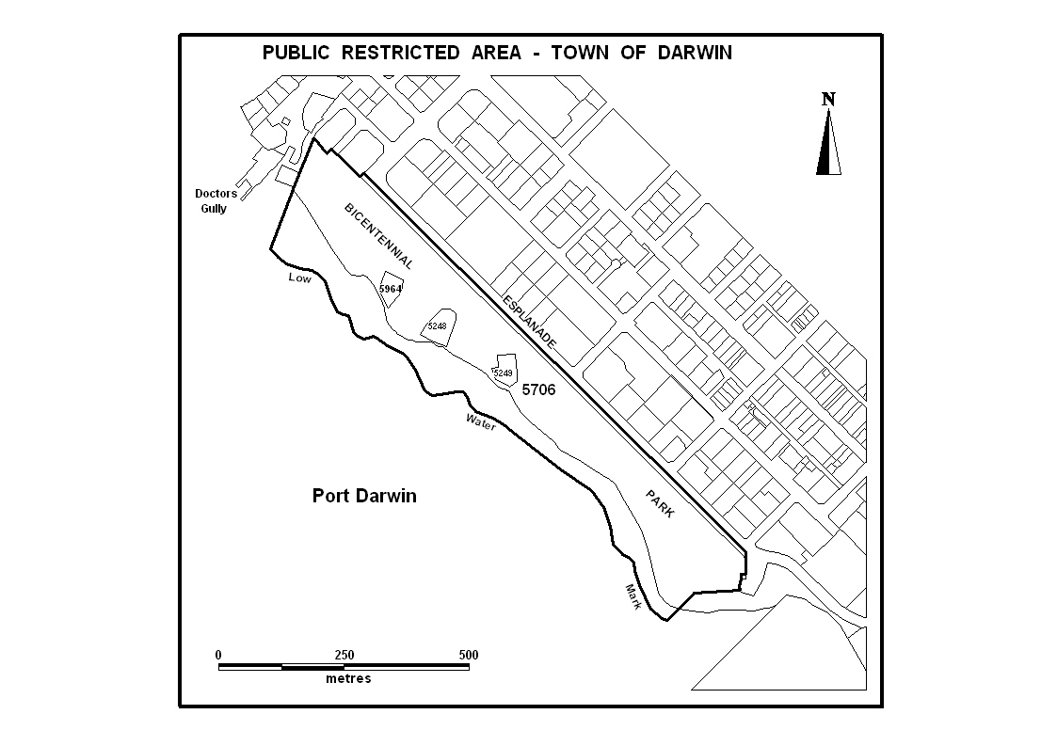
Figure 1 - Bicentennial Park Public Restricted Area - Town of Darwin
ii) Nightcliff / Coconut Grove
- All that area of land near Nightcliff in the Northern Territory of Australia bounded by lines described as follows: commencing at the intersection of the centrelines of Progress Drive and Dick Ward Drive; thence southerly by the centreline of Dick Ward Drive to a point due east of the most northern corner of Lot 9426 Town of Nightcliff; thence west to the said corner and generally westerly and south-westerly by southern and south-eastern boundaries of Orchard Road to the most eastern corner of Lot 9776; thence generally southerly by eastern boundaries of Lots 9776 and 9783 to its most eastern corner; thence westerly by the southern boundary of Lot 9783 and its prolongation westerly to a line 300 metres westerly of and parallel to the adjacent High Water Mark of Beagle Gulf; thence generally northerly by the said line to the south-westerly prolongation of the centreline of the most western leg of Aralia Street; thence north-easterly by the said prolongation to the centreline of Casuarina Drive; thence generally south-easterly by the said centreline and its prolongation to the south-westerly prolongation of the south-eastern boundary of Lot 4634; thence north-easterly by the said prolongation and boundary and its prolongation to the centreline of Banksia Street; thence generally south-easterly by the centrelines of Banksia Street and Casuarina Drive to the centreline of Progress Drive; thence easterly by the said centreline to the centreline of Phoenix Street; thence northerly, easterly and southerly by the centrelines of Phoenix Street, Pavonia Place and Oleander Street to the centreline of Progress Drive; thence easterly to the point of commencement; and
- All that parcel of land known as Craig Easther Park in Coconut Grove in the Northern Territory of Australia being the whole of lot 9126 Town of Nightcliff more particularly delineated on survey plan S84/210 lodged with the Surveyor General, Darwin. Refer Figure 2.
iii) Rapid Creek Foreshore
All that parcel of land near Rapid Creek in the Town of Nightcliff, Northern Territory of Australia being the area contained within the north-eastern boundaries of Casuarina Drive and Rapid Creek Road between Chapman Road and Trower Road, the north-western boundary of Trower Road between Rapid Creek Road and the centreline of Rapid Creek, the centreline of Rapid Creek between its mouth and Trower Road, Low Water Mark of Beagle Gulf between the mouth of Rapid Creek and the northerly prolongation of the centreline of Chapman Road and the said prolongation. Refer Figure 3.
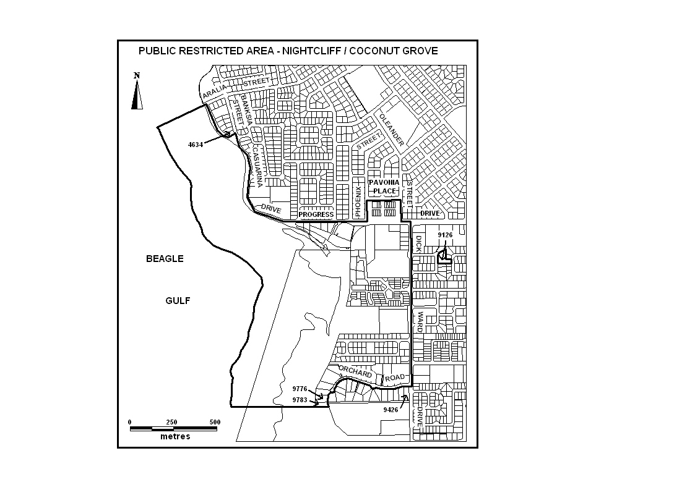
Figure 2 - Nightcliff/Coconut Grove Public Restricted Area
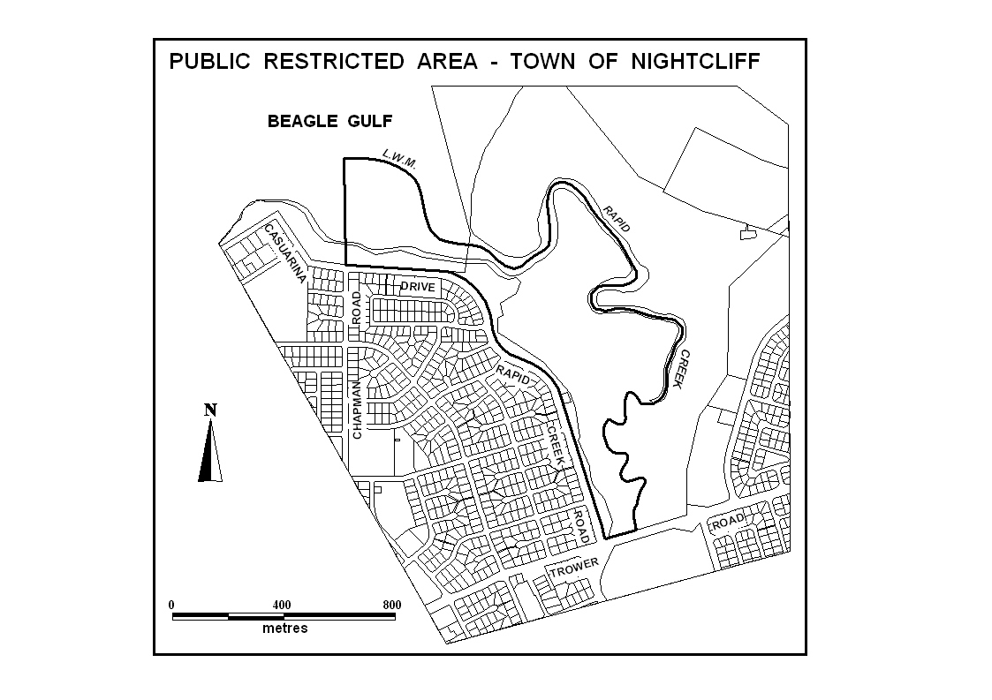
Figure 3 - Rapid Creek Foreshore Public Restricted Area
Richard O’Sullivan
Chairman
2 April 2008

