**Northern Territory**

**Correctional Services**

**Annual Statistics**

**2016 – 2017**



**Northern Territory Correctional Services**

**Annual Statistics**

**2016 - 2017**

© Northern Territory of Australia, Department of the Attorney-General and Justice, 2018

All rights reserved.

Whilst all reasonable care has been taken in the preparation of this report, the Northern Territory of Australia, its employees and agents do not warrant or represent that the report is free from errors or omission, or that it is exhaustive. No liability is assumed for any errors or omissions.

Produced by:

Criminal Justice Research and Statistics Unit

Northern Territory Government

GPO Box 1722

DARWIN NT 0801

Telephone: (08) 8935 7446

Website: <https://justice.nt.gov.au/attorney-general-and-justice/statistics-and-strategy>

**CONTENTS**

Annual Statistics 1

Introduction 1

Caseload Overview 3

Adult Prisoners 4

Population 4

Receptions 4

Imprisonment Rates 4

Aboriginal Status 5

Sentenced Prisoners 6

Offence 6

Last Known Address 6

Age 7

Sex 7

Marital Status 7

Foreign National Prisoners 8

Adult Foreign National Prisoners 8

Community Corrections orders 10

Caseload 10

Commencements 10

Aboriginal Status 10

Age 10

Sex 10

PERFORMANCE 11

SUPPORTING TABLES 14

Census of Adult Prisoners as at 30 June 2017 14

Adult Prisoner Turnover During 2016-17 20

Adult Prisoners During 2016-17 22

Community Corrections Caseload as at 30 June 2017 32

Community Corrections Turnover During 2016-17 34

APPENDIX 1 36

Offence Classifications 36

**TABLES**

Table 1 Summary of adult prisoner numbers in 2016-17 by correctional institution. 4

Table 2 Summary of estimated daily average foreign prisoners and detainees from 1996-97 to 2016-17*. 8

Table 3 National Performance Indicators. 12

Table 4 Census of prisoners by correctional institution, sentence status, Aboriginal status and gender. 14

Table 5 Census of prisoners by correctional institution and employment status at time of reception. 15

Table 6 Census of prisoners by correctional institution and age. 15

Table 7 Census of prisoners by correctional institution and marital status. 15

Table 8 Census of sentenced prisoners by correctional institution and aggregate sentence. 16

Table 9 Census of prisoners by correctional institution, last known address and Aboriginal status. 17

Table 10 Census of prisoners by offence and sentence status. 18

Table 11 Census of prisoners by correctional institution, Aboriginal status and type of sentence. 19

Table 12 Adult turnover summary. 20

Table 13 Adult escapes (incidents and persons). 20

Table 14 Adult receptions by sentence status, Aboriginal status and sex. 21

Table 15 Adult monthly daily average by correctional institution and sentence status. 22

Table 16 Adult releases by correctional institution, release reason and Aboriginal status. 24

Table 17 Distinct adults received by correctional institution, age, sex and Aboriginal status. 25

Table 18 Distinct adults received by correctional institution, place of origin and Aboriginal status. 26

Table 19 Summary of adult sentenced episode commencements by aggregate sentence and offence, 2016-17 27

Table 20 Adult sentenced episode commencements by aggregate sentence, Aboriginal status and offence, 2016-177 28

Table 21 Adult sentenced episodes held by aggregate sentence, offence and Aboriginal status, 2016-17 29

Table 22 Adult sentenced episodes commenced by aggregate sentence, offence and gender, 2016-17 30

Table 23 Community Corrections adult caseload by office, Aboriginal status and order. 32

Table 24 Community Corrections youth caseload by office, Aboriginal status and order. 33

Table 25 Community corrections order completions. 34

Table 26 Community corrections order commencements by Aboriginal status and gender. 35

Table 27 Distinct persons commencing a community corrections order by Aboriginal status and gender. 35

**FIGURES**

Figure 1 Northern Territory correctional services distinct client caseload 3

Figure 2 Yearly daily average adult prisoners from 1996-97 to 2016-17. 4

Figure 3 Estimated adult imprisonment rates by jurisdiction, 2016-17. 5

Figure 4 Estimated adult Aboriginal imprisonment rates by jurisdiction, 2016-17. 6

Figure 5 Estimated adult female imprisonment rates, 2011-12 to 2016-17. 7

Figure 6 Distribution of selected 'most serious offences' for foreign national prisoners and all adult prisoners 9

Figure 7 Community Corrections caseload (adult and youth) 10

Figure 8 Northern Territory Adult Prisoners as at 30 June 2017 14

Figure 9 Adult Monthly Daily Averages 2016-17 and 2015-16. 23

Figure 10 Monthly daily average of sentenced and unsentenced adults, 2016-17 23

Figure 11 Distribution of aggregate sentence commencements for adults according to selected offences and age* group, 2016-17 31

Figure 12 Northern Territory Community Corrections Caseload as at 30 June 2017. 34

Annual Statistics

Introduction

Prior to the August 2016 Northern Territory general election, the Northern Territory Department of Correctional Services (NTDCS) supervised both adults and youth who were subject to imprisonment/detention or community corrections orders.  Following the election, adult correctional services became a part of the Department of the Attorney-General and Justice, and youth justice services became part of Territory Families. As youth in community corrections continued under the supervision of the Department of Attorney-General and Justice through 2016-17, they have been included in this report. Youth detention statistics have been reported separately via Territory Families.

Persons in custody are located at:

Adults -

* Alice Springs Correctional Centre;
* Darwin Correctional Centre;
* Datjala Work Camp (Nhulunbuy); and
* Barkly Work Camp.

The non-custodial orders are administered by officers located in eight offices throughout the Northern Territory (NT):

* Palmerston and Top End Region (Jabiru, Maningrida, Oenpelli, Tiwi Islands);
* Casuarina;
* Alice Springs;
* Katherine;
* Tennant Creek;
* Groote Eylandt (Alyangula);
* Wadeye (Port Keats); and
* Nhulunbuy.

This report presents detailed statistics on adults and youths supervised by NTDCS during  
2016-17. Data from 2015-16 are supplied for comparison purposes as well as some long term data to show trends.

Statistics in this report include demographic characteristics of prisoners and community corrections clients, receptions, sentence status, offence types, last known address, caseload, community corrections client turn over, imprisonment rates and sentence durations.

The majority of the data are extracted from the Integrated Offender Management System (IOMS). Some internal data compiled by corrections staff are also used (eg escape information, daily averages).

National rates of imprisonment compiled by the Australian Bureau of Statistics (ABS) are provided for comparison with Northern Territory rates.

Selected characteristics in relation to the NT and other jurisdictions for 2016-17 from the ‘Report on Government Services’ are presented in this report.

Care should be taken when comparing information from this with other publications (eg ABS publications, Department of Correctional Services Annual Report and Report on Government Services), as different data collection timeframes, data extractions dates, different data sources or different counting methods may have been used.

The tables provided in this publication relating to the census of prisoners held on 30 June 2017 only include prisoners held in Northern Territory correctional centres. It does not include five prisoners who were held in Police Prisons on the night of 30 June 2017. These police prisoners are included in the ABS publication “Prisoners in Australia” therefore some differences may occur between figures in this report and figures published by the ABS.

The basis for reporting on offences is the Most Serious Offence (MSO) for the episode as recorded in IOMS. To enable national comparability, reporting on offences is in accordance with the Australian and New Zealand Standard Offence Classification (ANZSOC) divisions and selected subdivisions. Offence table abbreviations and classifications can be found in Appendix 1.

The totals in some tables (eg daily averages) may differ to the sum of the components due to rounding of the values of the components.

This comprehensive set of statistics is primarily used by corrections and youth justice staff for tactical and strategic planning relating to correctional services and youth justice services in the Northern Territory. Researchers and practitioners from other jurisdictions may also find this publication informative.

This report was compiled by the Criminal Justice Research and Statistics Unit, Northern Territory Government, and is available via the website:

<https://justice.nt.gov.au/attorney-general-and-justice/statistics-and-strategy/criminal-justice-statistics>

Further information relating to youth detention is available from Territory Families.

Caseload Overview

On 30 June 2017, the Northern Territory correctional services caseload consisted of 2,822 distinct persons, either adults or youth undertaking a community corrections order or adults in custody in a correctional centre. This is estimated as 1,353 per 100,0000F[1] persons in the Northern Territory. Note that as youth detainees are not included in this figure, it is not comparable with caseload rates published in previous years.

Figure 1 Northern Territory correctional services distinct client caseload

as at 30 June 2017.

Adult Prisoners

Population

The daily average number of prisoners held in adult correctional institutions in the Northern Territory in 2016-17 was 1,639, which was 1% less than the previous year (1,663). The following figure shows that prison population has only experienced a year-on-year reduction twice during the twenty year period and in general has steadily been increasing over the past 20 years..

Figure 2 Yearly daily average adult prisoners from 1996-97 to 2016-17.

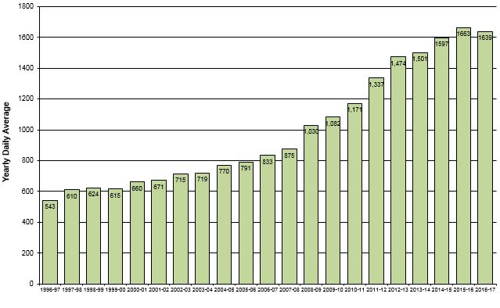

The minimum and maximum number of prisoners that were held in custody in an adult correctional institution in the Northern Territory on any day during 2016-17 was 1,565 and 1,725 respectively. The average occupancy level of the combined correctional institutions was 99% during the year.

Table 1 Summary of adult prisoner numbers in 2016-17 by correctional institution.

|  |  |  |  |  |  |
| --- | --- | --- | --- | --- | --- |
| **Correctional Institution** | **Minimum** | **Maximum** | **Daily Average** | **Design Capacity** | **Average Occupancy Level** |
| Alice Springs Correctional Centre | 510 | 588 | 556.1 | 500 | 111% |
| Darwin Correctional Centre | 905 | 1045 | 978.9 | 1048 | 93% |
| Barkly Work Camp | 54 | 77 | 69.7 | 50 | 139% |
| Datjala Work Camp | 29 | 41 | 34.5 | 50 | 69% |
| **All Centres** | **1565** | **1725** | **1639** | **1648** | **99%** |

Receptions

There were 4,235 receptions into Northern Territory adult correctional institutions during 2016-17, a decrease of 1% from the previous year. These receptions involved 3,246 distinct persons.

Imprisonment Rates

The rate of imprisonment1F[2] of adults in the Northern Territory for 2016-17 is estimated to be 903 per 100,000 adults, which continues to be significantly higher than in other jurisdictions (see Figure 3 below). The Northern Territory however, was the only jurisdiction to experience a reduction in the imprisonment rate (2.0%) in 2016-17 compared with the previous year. The national rate of imprisonment is estimated at 213 per 100,000 adults.

Figure 3 Estimated adult imprisonment rates by jurisdiction, 2016-17.

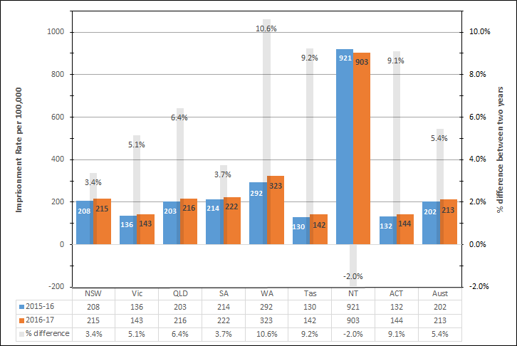

*Estimates of imprisonment rate per 100,000 adult population based on ABS Corrective Services Australia (4512.0).*

Aboriginal Status

The daily average number of Aboriginal prisoners in custody during 2016-17 was 1,376, which represented 84% of the total daily average.

On 30 June 2017, there were 1,343 Aboriginal prisoners in custody in an adult correctional institution in the Northern Territory, which represented 84% of total prisoners.

The figure below shows that the 2016-17 estimated rate of imprisonment of Aboriginal adults in the Northern Territory was 2,844 persons per 100,000 Aboriginal adults, which is 18% more than the national average of 2,409 persons per 100,000 Aboriginal adults. Although the NT had the highest overall imprisonment rate (Figure 3), this is due to the difference in population structure between the NT and other jurisdictions. The NT did not have the highest rate of Aboriginal imprisonment, being 29% less than the rate in Western Australia (Figure 4).

The estimated 2016-17 Northern Territory non‑Aboriginal rate of imprisonment was 198 per 100,000 non‑Aboriginal adults, compared with the national rate of 158 per 100,0002F[3]. Again, the NT’s non-Aboriginal imprisonment rate is less than that of Western Australia, based on the prisoner census of 30 June 2017.

Figure 4 Estimated adult Aboriginal imprisonment rates by jurisdiction, 2016-17.

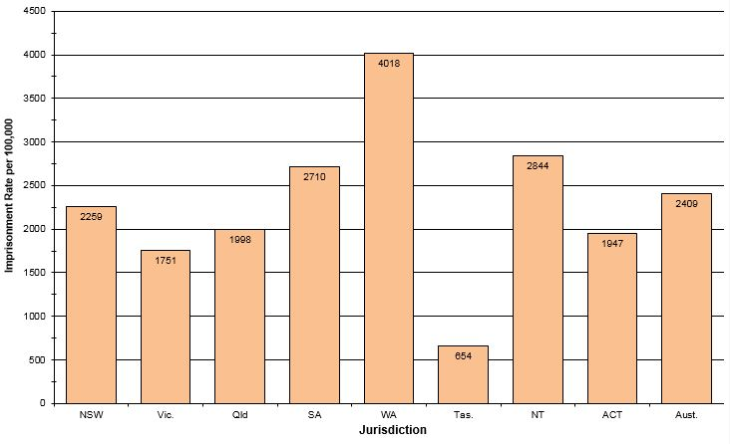

*Estimates of imprisonment rate per 100,000 adult Aboriginal population based on ABS Corrective Services Australia (4512.0).*

Sentenced Prisoners

On 30 June 2017, sentenced prisoners represented 71% of those in custody. Of these, 38% had an aggregate sentence of less than 12 months.

During 2016-17, sentenced prisoners represented 62% of the receptions and 71% of the daily average number of prisoners in adult correctional institutions.

The average aggregate sentence length for prisoners sentenced to imprisonment during 2016-17 (excluding prisoners with life sentences) was 262 days, which is 22 days less than for the previous year (284 days). The median sentence length for these prisoners was 122 days in 2016-17, which is 12 days less than the median length for 2015-16. The average sentence length for Aboriginal prisoners sentenced to imprisonment in 2016-17 was 237 days.

The most common offence type for sentenced episode commencements was ‘Acts intended to cause injury’ which represented 42% of the commencements. The average aggregate sentence length was 273 days (which is slightly more than the previous year’s average of 267 days). ‘Murder’ and ‘Attempted murder’ overall received the longest aggregate sentences of life and more than 16 years, respectively.

The average aggregate sentence length for all sentenced prisoners held in custody during 2016-17 (excluding prisoners with life sentences) was 507 days and the median sentence length was 180 days, which is the same as it was for the previous year.

Offence

The most common offences3F[4] for prisoners held in custody on 30 June 2017 were ‘Acts intended to cause injury’ (47% of prisoners), followed by ‘Sexual assault and related offences’ (11% of prisoners) and ‘Offences against justice procedures, government security and operations’ (9% of prisoners).

Last Known Address

Alice Springs Police District was the most common location of last known address for prisoners held in custody on 30 June 2017, representing 18% (284) of prisoners in custody. This was followed by Casuarina Police District 8% (130), Palmerston Police District 8% (129) and Darwin Police District 7% (109).

Age

The average age of distinct prisoners received into custody during 2016-17 was 33 years. There were 41 distinct prisoners received into custody who were aged 60 years or older, with the oldest prisoner aged 80 at reception.

Sex

On 30 June 2017, there were 110 female prisoners in custody, which represented 7% of the Northern Territory prison population. During 2016-17, there were 287 sentenced female receptions, a 4% increase compared with the previous year (277).

The daily average number of adult females in custody during 2016-17 was 120, which was 12% lower than the previous year (136).During 2016-17, the average daily proportion of females in the Northern Territory prison population was 7.3% compared to the national average of 8.1% for the same period4F[5].

The average aggregate sentence length for adult females commencing a sentence in 2016-17 was 216 days, which is 25 days less than for the previous year.

The estimated Northern Territory female imprisonment rate for 2016-17 was 139 per 100,000 adult females, a decrease of 14% from the previous year. The estimated Australian rate for the same period was 34 per 100,000 adult females. Again, the discrepancy is due to the difference between the NT population structure and that of Australia as a whole. In 2016-17, the NT Aboriginal female imprisonment rate was 16% lower than the overall Australian imprisonment rate for Aboriginal females.

Figure 5 Estimated adult female imprisonment rates, 2011-12 to 2016-17.

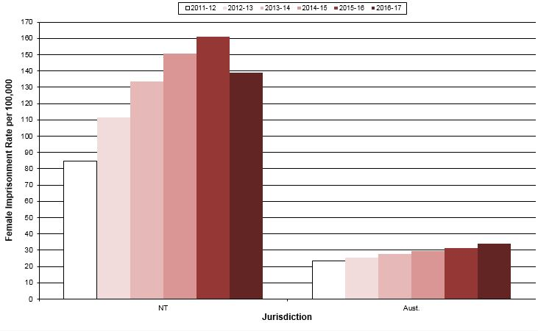

*Estimates of imprisonment rate per 100,000 adult female population based on ABS Corrective Services Australia (4512.0).*

Marital Status

On 30 June 2017, 51% of the prisoners had stated at the time of their reception into custody, that they were married.

Foreign National Prisoners

Foreign national prisoners are often held in Northern Territory correctional institutions and are included in the counts as non-Aboriginal. The yearly daily average number of foreign national prisoners reached a peak of 145 in 2000-01.

Table 2 Summary of estimated daily average foreign prisoners and detainees from 1996-97 to 2016-17*.

|  |  |  |  |  |  |
| --- | --- | --- | --- | --- | --- |
| **Year/Quarter** | **Foreign Citizens** | | | | **% of All Prisoners and Detainees\*** |
| **Federal Offence** | | **Non-Federal Offence** | **Total** |
| **People Smugglers** | **Other Federal** |  |  |
| 1996‑97 | 3 | 10 | 19 | 32 | 6% |
| 1997‑98 | 2 | 11 | 26 | 39 | 6% |
| 1998‑99 | 2 | 14 | 25 | 41 | 6% |
| 1999‑00 | 71 | 12 | 28 | 112 | 18% |
| 2000‑01 | 122 | 12 | 12 | 145 | 21% |
| 2001-02 | 121 | 14 | 6 | 141 | 20% |
| 2002-03 | 40 | 14 | 5 | 59 | 8% |
| 2003-04 | 6 | 12 | 8 | 26 | 3% |
| 2004-05 | 2 | 26 | 8 | 37 | 5% |
| 2005-06 | 1 | 9 | 9 | 18 | 2% |
| 2006-07 | 1 | 14 | 9 | 24 | 3% |
| 2007-08 | 1 | 11 | 8 | 21 | 3% |
| 2008-09 | 1 | 8 | 13 | 22 | 2% |
| 2009-10 | na | na | na | na | na |
| 2010-11 | 18 | 7 | 24 | 49 | 4% |
| 2011-12 | 35 | 8 | 21 | 64 | 5% |
| 2012-13 | 28 | 5 | 19 | 52 | 3% |
| 2013-14 | 3 | 8 | 20 | 31 | 2% |
| 2014-15 | 1 | 9 | 27 | 37 | 2% |
| 2015-16 | 0 | 9 | 31 | 40 | 2% |
| **2016-17** | **0** | **8** | **28** | **35** | **2%** |
| Sep. qtr 2016 | 0 | 6 | 29 | 35 | 2% |
| Dec. qtr 2016 | 0 | 6 | 27 | 33 | 2% |
| Mar. qtr 2017 | 0 | 9 | 30 | 39 | 2% |
| Jun. qtr 2017 | 0 | 9 | 26 | 35 | 2% |

na – not available.

Between 1999-00 and 2002-03, the majority of foreign national prisoners held in Northern Territory correctional institutions were classified as ‘people smugglers’. People smugglers are generally non‑Australian citizens in custody for federal ‘people smuggling’ offences5F[6]. There was a rapid increase in the number of receptions of people smugglers during the 1999‑00 financial year. During the period 1999‑00 to 2001‑02, people smugglers represented a significant proportion of the total custody population and a large proportion of the non-Aboriginal custody population. The yearly daily average number of people smugglers reached a peak of 122 in 2000-01. In 2016-17, the daily average number of people smugglers was zero.

*2016/17 excludes youth detainees.

Adult Foreign National Prisoners

On 30 June 2017, there were 28 foreign nationals in custody in an adult correctional institution, representing 2% of the total adult correctional institution population. Foreign nationals show a very different offending profile compared with the NT prison population as a whole (Figure 6).

Figure 6 Distribution of selected 'most serious offences' for foreign national prisoners and all adult prisoners

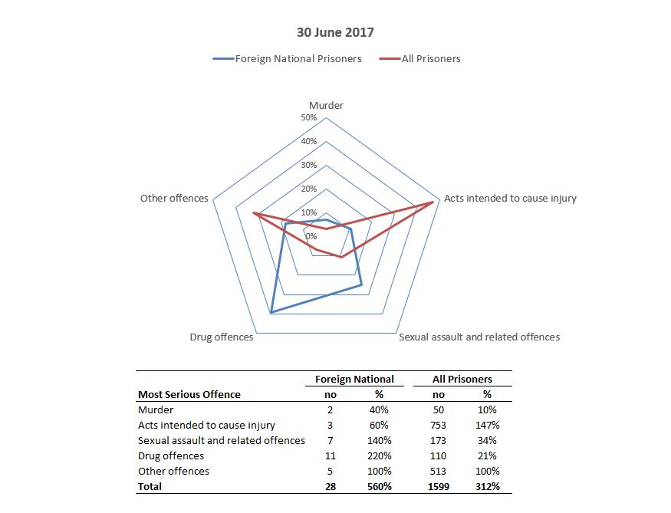

Community Corrections orders

Caseload

Figure 7 Community Corrections caseload (adult and youth)

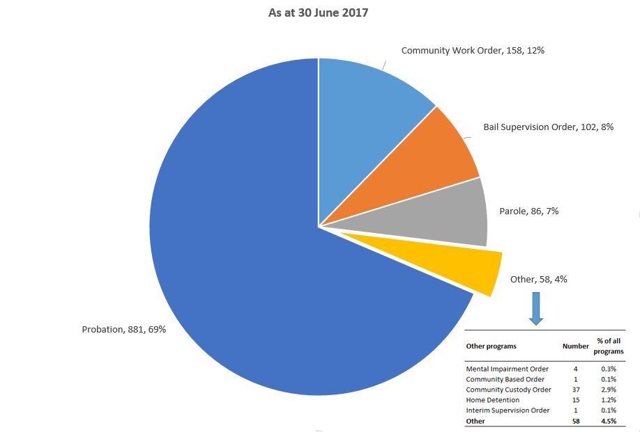

As at 30 June 2017, the Community Corrections caseload in the Northern Territory consisted of 1,151 adult orders and 136 youth orders. Of these, 881 (68%) were for probation orders (i.e. an order of release on bond/good behaviour or an order suspending a sentence with a supervision condition) and 158 (12%) were community work orders. An individual may have more than one type of order, including having an adult and a youth order at the same time. Thus the overall caseload on 30 June 2017 relates to 1,219 distinct persons. The adult and youth caseloads relate to 1,114 and 110 distinct persons, respectively.

Commencements

During 2016-17, there were 1,886 community corrections order commencements, 1% (12) more than the previous year. Probation orders increased by 6% (71) and community custody orders increased by 30% (24), whilst community work orders decreased by 13% (65) and parole orders decreased by 14% (19). Probation orders were the most common community corrections commencement comprising 63% (1,187).

Aboriginal Status

Aboriginal people represented 85% (1,594) of the community corrections order commencements.

Age

The majority (1,631 or 86%) of community corrections order commencements were for adults. The average and median age for distinct persons who commenced a community corrections order during 2016-17 was 30 years and 28 years respectively. The youngest person to commence an order was 11 years and the oldest was 72 years.

Sex

Females comprised 19% (364) of the community corrections order commencements for 2016-17.

PERFORMANCE

The following table contains information produced by the Steering Committee for the Review of Commonwealth/State Service Provision (SCRCSSP) contained in the ‘Report on Government Services, 2018’, which compares service delivery performance across jurisdictions in Australia. Each jurisdiction provides standard information by which comparisons can be made. For corrective services, performance is categorised according to efficiency or effectiveness. Key focus areas mentioned above are addressed by at least one indicator and a selection of summary indicators are presented in the following table.

The information presented in the following table for other jurisdictions is for 2016-17. The Agency uses many of the findings from this exercise to establish benchmarks for its own business planning exercises.

In many instances, the Northern Territory differs from other jurisdictions. These unique characteristics include the small general population of which a high proportion is comprised of Aboriginal persons, dispersion of the population and remoteness, which results in higher costs for goods and services, and the physical location of the Northern Territory in comparison to other states.

It should also be noted that some of the indicators used in the following table might differ from those used elsewhere in this Annual Report

As can be seen, the Northern Territory compares reasonably with other jurisdictions in most of the performance indicators mentioned above. The measure of recidivism is seen to be a partial measure of the whole justice system, not just the correctional system. It is recognised that the rates of recidivism are influenced by many factors outside the justice system, including health, education, employment, and other social issues. The measures of recidivism used are limited in that they do not consider the types of re-offending; they only follow a person within the same jurisdiction in which they completed the original corrections program; and they do not include any offences which result in an outcome not administered by correctional services.

Table 3 National Performance Indicators.



*na – not available*

*- – nil or rounded to 0*

**Notes for Table 3:**

1. All prisoners released following a period of sentenced imprisonment who return to prison in the same jurisdiction within 2 years of their release.
2. Offenders returning to a community corrections order in the same jurisdiction within 2 years of them successfully completing a community corrections order.
3. Relevant population refers to all persons aged 18 years and over in all states and territories with the exception of Queensland where the adult population is aged 17 years and over.
4. Per 100 prisoners and refers to prisoners, not incidents. Rate is determined by the number of prisoners divided by prisoner daily average (open or secure).
5. Per 100 prisoners and is determined by the number of deaths divided by the prisoner daily average.
6. Figures are based on the number of prisoners in education on a single day, calculated against the number of prisoners in custody on that day (generally based on data from the last day of term prior to 30 June each year).
7. Excludes operating revenues, payroll tax and expenditure on prisoner health and on transport and escort services where able to be disaggregated by jurisdictions.
8. Capital costs not included.
9. Community supervision counts distinct persons not orders and for the Northern Territory, home detention clients are included in this group.
10. Northern Territory figures do not include clients whose order has been in suspense (breach) for three years or more.

SUPPORTING TABLES

Table 4 Census of prisoners by correctional institution, sentence status, Aboriginal status and gender.

|  |  |  |  |  |  |  |  |  |  |  |  |  |  |  |
| --- | --- | --- | --- | --- | --- | --- | --- | --- | --- | --- | --- | --- | --- | --- |
| **Correctional institution/**  **Sentence Status** | **Aboriginal** | |  | **Non-Aboriginal** | |  | **All** | |  | **Total 2017** | |  | Total 2016 | |
| **Male** | **Female** |  | **Male** | **Female** |  | **Male** | **Female** |  | **Number** | **% of Total** |  | Number | % of Total |
| **Alice Springs Correctional Centre** |  |  |  |  |  |  |  |  |  |  |  |  |  |  |
| Sentenced | 322 | 27 |  | 24 | 1 |  | 346 | 28 |  | **374** |  |  | 432 |  |
| Unsentenced | 123 | 8 |  | 15 | 3 |  | 138 | 11 |  | **149** |  |  | 148 |  |
| Total | 445 | 35 |  | 39 | 4 |  | 484 | 39 |  | **523** | **32.7%** |  | 580 | 35.0% |
|  |  |  |  |  |  |  |  |  |  |  |  |  |  |  |
| **Darwin Correctional Centre** |  |  |  |  |  |  |  |  |  |  |  |  |  |  |
| Sentenced | 473 | 37 |  | 140 | 8 |  | 613 | 45 |  | **658** |  |  | 676 |  |
| Unsentenced | 229 | 21 |  | 57 | 5 |  | 286 | 26 |  | **312** |  |  | 310 |  |
| Total | 702 | 58 |  | 197 | 13 |  | 899 | 71 |  | **970** | **60.7%** |  | 986 | 59.5% |
|  |  |  |  |  |  |  |  |  |  |  |  |  |  |  |
| **Barkly Work Camp** |  |  |  |  |  |  |  |  |  |  |  |  |  |  |
| Sentenced | 71 | 0 |  | 0 | 0 |  | 71 | 0 |  | **71** |  |  | 56 |  |
| Unsentenced | 0 | 0 |  | 0 | 0 |  | 0 | 0 |  | **0** |  |  | 0 |  |
| Total | 71 | 0 |  | 0 | 0 |  | 71 | 0 |  | **71** | **4.4%** |  | 56 | 3.4% |
|  |  |  |  |  |  |  |  |  |  |  |  |  |  |  |
| **Datjala Work Camp** |  |  |  |  |  |  |  |  |  |  |  |  |  |  |
| Sentenced | 32 | 0 |  | 3 | 0 |  | 35 | 0 |  | **35** |  |  | 36 |  |
| Unsentenced | 0 | 0 |  | 0 | 0 |  | 0 | 0 |  | **0** |  |  | 0 |  |
| Total | 32 | 0 |  | 3 | 0 |  | 35 | 0 |  | **35** | **2.2%** |  | 36 | 2.2% |
|  |  |  |  |  |  |  |  |  |  |  |  |  |  |  |
| **Total 30 June 2017** |  |  |  |  |  |  |  |  |  |  |  |  |  |  |
| **Sentenced** | **898** | **64** |  | **167** | **9** |  | **1065** | **73** |  | **1138** |  |  |  |  |
| **Unsentenced** | **352** | **29** |  | **72** | **8** |  | **424** | **37** |  | **461** |  |  |  |  |
| **Total** | **1250** | **93** |  | **239** | **17** |  | **1489** | **110** |  | **1599** | **100%** |  |  |  |
| Total 30 June 2016 |  |  |  |  |  |  |  |  |  |  |  |  |  |  |
| Sentenced | 944 | 71 |  | 174 | 11 |  | 1118 | 82 |  |  |  |  | 1200 |  |
| Unsentenced | 342 | 33 |  | 72 | 11 |  | 414 | 44 |  |  |  |  | 458 |  |
| Total | 1286 | 104 |  | 246 | 22 |  | 1532 | 126 |  |  |  |  | 1658 | 100% |

***Sentenced*** *– Includes prisoners detained in custody at the Administrator's pleasure and persons in custody for fine default.*

Census of Adult Prisoners as at 30 June 2017

* There were 4% less prisoners in custody in Northern Territory correctional institutions on   
  30 June 2017 than for the same day last year.
* Males represented 93% of the prisoners on 30 June 2017.
* On 30 June 2017, 71% of prisoners were sentenced.
* The number of sentenced prisoners decreased by 5% whereas unsentenced prisoners increased by 1% compared to the previous year.

Figure 8 Northern Territory Adult Prisoners as at 30 June 2017

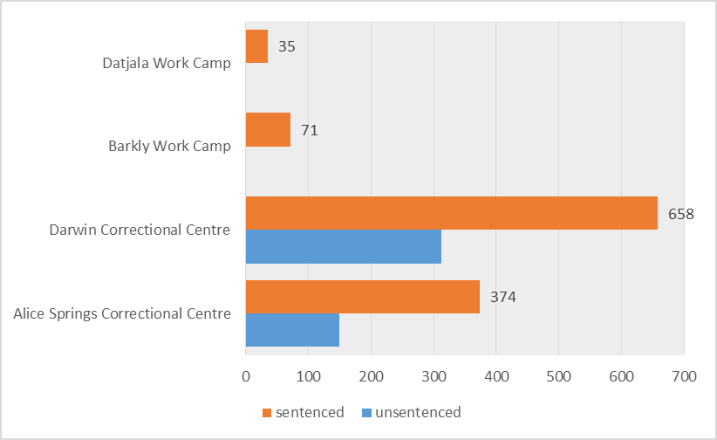

Table 5 Census of prisoners by correctional institution and employment status at time of reception.

|  |  |  |  |  |  |  |  |
| --- | --- | --- | --- | --- | --- | --- | --- |
| **Correctional institution** | **Employment Status** | | | |  | **Total** | |
| **Employed** | **Unemployed** | **Other** | **Not Stated** |  | **2017** | 2016 |
| Alice Springs Correctional Centre | 137 | 351 | 34 | 1 |  | **523** | 580 |
| Darwin Correctional Centre | 246 | 608 | 114 | 2 |  | **970** | 986 |
| Barkly Work Camp | 13 | 56 | 2 | 0 |  | **71** | 56 |
| Datjala Work Camp | 6 | 25 | 4 | 0 |  | **35** | 36 |
|  |  |  |  |  |  |  |  |
| **Total 30 June 2017** | **402** | **1040** | **154** | **3** |  | **1599** |  |
| Total 30 June 2016 | 411 | 1077 | 165 | 5 |  |  | 1658 |

***Other*** *– Includes students, pensioners and home duties.*

* Aboriginal prisoners represented 84% of the total prison population on the nights of   
  30 June 2017 and 30 June 2016.
* On 30 June 2017, 65% of prisoners held in custody indicated that they were unemployed at time of reception.

Table 6 Census of prisoners by correctional institution and age.

|  |  |  |  |  |  |  |  |  |  |  |
| --- | --- | --- | --- | --- | --- | --- | --- | --- | --- | --- |
| **Correctional institution** | **Age Group (years)** | | | | | | |  | **Total** | |
| **<18** | **18-19** | **20-29** | **30-39** | **40-49** | **50-59** | **60+** |  | **2017** | 2016 |
| Alice Springs Correctional Centre | 0 | 27 | 164 | 183 | 107 | 34 | 8 |  | **523** | 580 |
| Darwin Correctional Centre | 0 | 29 | 339 | 302 | 187 | 95 | 18 |  | **970** | 986 |
| Barkly Work Camp | 0 | 1 | 24 | 30 | 15 | 1 | 0 |  | **71** | 56 |
| Datjala Work Camp | 0 |  | 11 | 15 | 8 | 1 | 0 |  | **35** | 36 |
|  |  |  |  |  |  |  |  |  |  |  |
| **Total 30 June 2017** | **0** | **57** | **538** | **530** | **317** | **131** | **26** |  | **1599** |  |
| Total 30 June 2016 | 0 | 48 | 583 | 544 | 339 | 118 | 26 |  |  | 1658 |

* On 30 June 2017, 26 prisoners aged 60 years or more were in custody, of who the eldest was 74 years old.
* On 30 June 2017, 67% of prisoners held in custody were between 20 and 39 years of age.

Table 7 Census of prisoners by correctional institution and marital status.

|  |  |  |  |  |  |  |  |  |
| --- | --- | --- | --- | --- | --- | --- | --- | --- |
| **Correctional institution** | **Marital Status** | | | | |  | **Total** | |
| **Never Married** | **Married** | **Separated Divorced** | **Widowed** | **Unknown** |  | **2017** | 2016 |
| Alice Springs Correctional Centre | 191 | 300 | 28 | 2 | 2 |  | **523** | 580 |
| Darwin Correctional Centre | 445 | 450 | 68 | 6 | 1 |  | **970** | 986 |
| Barkly Work Camp | 19 | 46 | 6 | 0 | 0 |  | **71** | 56 |
| Datjala Work Camp | 8 | 23 | 4 | 0 | 0 |  | **35** | 36 |
|  |  |  |  |  |  |  |  |  |
| **Total 30 June 2017** | **663** | **819** | **106** | **8** | **3** |  | **1599** |  |
| Total 30 June 2016 | 673 | 871 | 101 | 11 | 2 |  |  | 1658 |

* On 30 June 2017, 51% of prisoners held in custody stated at the time of their reception that they were married.

Table 8 Census of sentenced prisoners by correctional institution and aggregate sentence.

|  |  |  |  |  |  |  |  |  |  |  |  |  |  |
| --- | --- | --- | --- | --- | --- | --- | --- | --- | --- | --- | --- | --- | --- |
| **Correctional institution** | **Aggregate Sentence** | | | | | | | | |  | **Total** | | |
| **Months** | | | | **Years** | | | **Indefinite** | |  | **Number** | **Days** | |
| **<1** | **1<3** | **3<6** | **6<12** | **1<2** | **2<5** | **5+** | **Other** | **Life** |  | **Mean** | **Median** |
| Alice Springs Correctional Centre | 8 | 24 | 77 | 79 | 56 | 70 | 48 | 2 | 10 |  | **374** | 810 | 335 |
| Darwin Correctional Centre | 9 | 23 | 77 | 81 | 68 | 179 | 169 | 18 | 34 |  | **658** | 1377 | 1072 |
| Barkly Work Camp | 0 | 2 | 23 | 20 | 15 | 11 | 0 | 0 | 0 |  | **71** | 390 | 244 |
| Datjala Work Camp | 0 | 1 | 1 | 11 | 13 | 6 | 3 | 0 | 0 |  | **35** | 758 | 456 |
|  |  |  |  |  |  |  |  |  |  |  |  |  |  |
| **Total 30 June 2017** | **17** | **50** | **178** | **191** | **152** | **266** | **220** | **20** | **44** |  | **1138** | **1101** | **547** |
| Total 30 June 2016 | 30 | 72 | 157 | 196 | 200 | 265 | 223 | 17 | 40 |  | 1200 | 1065 | 547 |

***Aggregate sentence*** *– The longest period that the offender may be detained under sentence in the current episode.*

***Other*** *– Includes prisoners detained at the Administrator's pleasure, indefinite sentences subject to Judicial Review and*

*post detention orders.*

***Days (Mean, Median)*** *– Does not include indeterminate sentences (Life, Administrator's Pleasure and indefinite sentence).*

* There was a decrease of 5% in the number of sentenced prisoners held on 30 June 2017 compared with 30 June 2016.
* On 30 June 2017, 25% of the sentenced prisoners held in custody had an aggregate sentence of five years or longer (including indefinite sentences).
* There was a 43% decrease in the number of prisoners with an aggregate sentence of less than   
  1 month on 30 June 2017, compared with 30 June 2016. Note: In 2017, the methodology for the calculation of time ranges was updated to improve accuracy.
* Prisoners with an aggregate sentence of 12 months or less, comprised 38% of total sentenced prisoners.
* The median aggregate sentence of sentenced prisoners held at the Barkly Work Camp decreased by 43% from the same time last year.



***Last known address*** *– As recorded in IOMS and aggregated into Police districts.*

**Table 9 Census of prisoners by correctional institution, last known address and Aboriginal status.**

* Alice Springs Police District was the most common last known address for prisoners held in custody on 30 June 2017, representing 18% (284) of prisoners in custody. This was followed by Casuarina Police District at 8% (130), Palmerston Police District at 8% (129), and Darwin Police District at 7% (109).

Table 10 Census of prisoners by offence and sentence status.

|  |  |  |  |  |  |  |  |  |  |  |  |
| --- | --- | --- | --- | --- | --- | --- | --- | --- | --- | --- | --- |
| **Most Serious Offence** | | | | **Sentenced** | |  | **Unsentenced** | |  | **Total** | |
| **2017** | 2016 |  | **2017** | 2016 |  | **2017** | 2016 |
| Homicide and related offences | | | |  |  |  |  |  |  |  |  |
|  | Murder | | | **45** | 41 |  | **5** | 14 |  | **50** | 55 |
|  | Attempted Murder | | | **3** | 3 |  | **6** | 4 |  | **9** | 7 |
|  | Manslaughter and driving causing death | | | **52** | 48 |  | **1** | 1 |  | **53** | 49 |
| Acts intended to cause injury | | | | **473** | 519 |  | **280** | 253 |  | **753** | 772 |
| Sexual assault and related offences | | | | **126** | 131 |  | **47** | 53 |  | **173** | 184 |
| Dangerous or negligent acts endangering persons | | | |  |  |  |  |  |  |  |  |
|  | Driving under the influence of alcohol or drugs | | | **1** | 0 |  | **1** | 0 |  | **2** | 0 |
|  | Dangerous or negligent driving | | | **13** | 13 |  | **4** | 8 |  | **17** | 21 |
|  | Other | | | **31** | 32 |  | **6** | 2 |  | **37** | 34 |
| Abduction and related offences | | | | **6** | 2 |  | **4** | 5 |  | **10** | 7 |
| Robbery extortion and related offences | | | | **30** | 30 |  | **15** | 9 |  | **45** | 39 |
| Unlawful entry with intent | | | | **44** | 55 |  | **17** | 25 |  | **61** | 80 |
| Theft and related offences | | | |  |  |  |  |  |  |  |  |
|  | Motor vehicle theft and related offences | | | **14** | 4 |  | **3** | 3 |  | **17** | 7 |
|  | Other | | | **8** | 7 |  | **3** | 1 |  | **11** | 8 |
| Deception and related offences | | | | **3** | 9 |  | **1** | 4 |  | **4** | 13 |
| Illicit drug offences | | | | **59** | 57 |  | **51** | 52 |  | **110** | 109 |
| Weapons and explosive offences | | | | **2** | 2 |  | **2** | 7 |  | **4** | 9 |
| Property damage and environmental pollution | | | | **32** | 41 |  | **6** | 4 |  | **38** | 45 |
| Public order offences | | | | **9** | 6 |  | **0** | 1 |  | **9** | 7 |
| Road traffic and motor vehicle regulatory offences | | | |  |  |  |  |  |  |  |  |
|  | Driving licence offences | | | **29** | 36 |  | **0** | 0 |  | **29** | 36 |
|  | Exceeding the prescribed content of alcohol | | | **20** | 26 |  | **3** | 5 |  | **23** | 31 |
|  | Other | | | **2** | 2 |  | **0** | 0 |  | **2** | 2 |
| Offences against justice procedures, gov't security and operations | | | |  |  |  |  |  |  |  |  |
|  | Breach of justice order | | | **126** | 130 |  | **5** | 7 |  | **131** | 137 |
|  | Other | | | **9** | 6 |  | **0** | 0 |  | **9** | 6 |
| Miscellaneous offences | | | | **1** | 0 |  | **0** | 0 |  | **1** | 0 |
| Other | | | | **0** | 0 |  | **1** | 0 |  | **1** | 0 |
|  | |  | |  |  |  |  |  |  |  |  |
| **Total 30 June 2017** | | | | **1138** |  |  | **461** |  |  | **1599** |  |
| Total 30 June 2016 | | |  |  | 1200 |  |  | 458 |  |  | 1658 |

***Most serious offence*** *– As recorded in IOMS.*

***Sentenced*** *– Includes prisoners detained at the Administrator's pleasure, indefinite sentences subject to Judicial Review,*

*post detention orders and fine default.*

* The most common offence type for people held in custody on 30 June 2017 was 'Acts intended to cause injury' which represented 47% of the total prisoner population. This was followed by ‘Sexual assault and related offences’ representing 11%.
* There was a 9% decrease in the number of sentenced people in custody for 'Acts intended to cause injury' ie. 473 on 30 June 2017 compared with 519 on 30 June 2016.

Table 11 Census of prisoners by correctional institution, Aboriginal status and type of sentence.



***Fine default*** *– Those prisoners who are serving a sentence for non-payment of a fine and are subject to no other sentence at the time. Offenders who are serving fine default sentences while on remand are counted as sentenced (fine default) prisoners.*

***Max-Min*** *– Maximum term specified and minimum term or non-parole period set.*

***Fixed term*** *– No post-release follow-up period set.*

***Indefinite - Other*** *– Includes prisoners detained at the Administrator's pleasure, subject to Judicial Review and post detention.*

***Indefinite -Parole*** *– Prisoners who have received a life sentence with a non-parole period set.*

* Of those who were unsentenced, 83% were Aboriginal.
* Aboriginal prisoners comprised 94% of those with fixed term sentences and 81% of those with max-min sentences.
* There was a 7% decrease in the number of 'Fixed Term' sentences, ie 396 on 30 June 2017compared to 424 on 30 June 2016.
* ‘Max-Min' sentences represented the most common type of sentence.

Adult Prisoner Turnover During 2016-17

Table 12 Adult turnover summary.

|  |  |  |  |  |  |  |  |  |  |
| --- | --- | --- | --- | --- | --- | --- | --- | --- | --- |
|  |  | **Aboriginal** | |  | **Non-Aboriginal** | |  | **Total** |  |
|  |  | **Male** | **Female** |  | **Male** | **Female** |  | **2016-17** |  |
| Held at 30 June 2016 | Adult | 1286 | 104 |  | 246 | 22 |  | **1658** |  |
|  |  |  |  |  |  |  |  |  |  |
|  |  |  |  |  |  |  |  |  |  |
| Received during 2016-17 | Adult | 3168 | 481 |  | 513 | 73 |  | **4235** |  |
|  |  |  |  |  |  |  |  |  |  |
| Youth to adult | Youth | 7 | 0 |  | 1 | 0 |  | **8** |  |
|  |  |  |  |  |  |  |  |  |  |
|  |  |  |  |  |  |  |  |  |  |
| Releases during 2016-17 | Adult | 3211 | 492 |  | 521 | 78 |  | **4302** |  |
|  |  |  |  |  |  |  |  |  |  |
|  |  |  |  |  |  |  |  |  |  |
| **Held at 30 June 2017** | **Adult** | **1250** | **93** |  | **239** | **17** |  | **1599** |  |
|  |  |  |  |  |  |  |  |  |  |
|  |  |  |  |  |  |  |  |  |  |

***Youth to adult*** *– Youths transferring to adult prisons while in custody.*

Table 13 Adult escapes (incidents and persons).

|  |  |  |  |  |  |  |
| --- | --- | --- | --- | --- | --- | --- |
|  | **Financial Year** | **Alice Springs Correctional Centre** | **Darwin Correctional Centre** | **Barkly Work Camp1** | **Datjala Work Camp2** | **Total** |
| **Incidents** | **2016-17** | **6** | **4** | **0** | **1** | **11** |
|  | 2015-16 | 4 | 6 | 1 | 1 | 12 |
|  | 2014-15 | 5 | 3 | 2 | 1 | 11 |
|  | 2013-14 | 2 | 3 | 9 | - | 14 |
|  | 2012-13 | 1 | 2 | 2 | - | 5 |
|  | 2011-12 | 2 | 1 | 2 | - | 5 |
|  | 2010-11 | 5 | 2 | 0 | - | 7 |
|  | 2009-10 | 3 | 1 | - | - | 4 |
|  | 2008-09 | 2 | 1 | - | - | 3 |
|  | 2007-08 | 1 | 0 | - | - | 1 |
|  | 2006-07 | 3 | 1 | - | - | 4 |
|  | 2005-06 | 2 | 2 | - | - | 4 |
|  | 2004-05 | 2 | 0 | - | - | 2 |
|  | 2003-04 | 1 | 1 | - | - | 2 |
|  | 2002-03 | 2 | 0 | - | - | 2 |
|  | 2001-02 | 2 | 1 | - | - | 3 |
|  | 2000-01 | 2 | 0 | - | - | 2 |
|  | 1999-00 | 0 | 0 | - | - | 0 |
|  | 1998-99 | 0 | 0 | - | - | 0 |
|  | 1997-98 | 0 | 1 | - | - | 1 |
|  |  |  |  |  |  |  |
| **Persons** | **2016-17** | **8** | **4** | **0** | **3** | **15** |
|  | 2015-16 | 5 | 11 | 1 | 1 | 18 |
|  | 2014-15 | 5 | 3 | 2 | 2 | 12 |
|  | 2013-14 | 2 | 4 | 18 | - | 24 |
|  | 2012-13 | 1 | 2 | 6 | - | 9 |
|  | 2011-12 | 2 | 2 | 2 | - | 6 |
|  | 2010-11 | 7 | 2 | 0 | - | 9 |
|  | 2009-10 | 3 | 1 | - | - | 4 |
|  | 2008-09 | 2 | 2 | - | - | 4 |
|  | 2007-08 | 1 | 0 | - | - | 1 |
|  | 2006-07 | 4 | 1 | - | - | 5 |
|  | 2005-06 | 2 | 5 | - | - | 7 |
|  | 2004-05 | 2 | 0 | - | - | 2 |
|  | 2003-04 | 1 | 1 | - | - | 2 |
|  | 2002-03 | 2 | 0 | - | - | 2 |
|  | 2001-02 | 2 | 1 | - | - | 3 |
|  | 2000-01 | 2 | 0 | - | - | 2 |
|  | 1999-00  1998-99  1997-98 | 0  0  0 | 0  0  1 | -  -  - | -  -  - | 0  0  1 |

*Escapes include incidents that occur under escort and from hospital.*

*Note: 1. The Barkly Work Camp commenced operation in April 2011.*

*2. Escape data for the Datjala Work Camp was not recorded until after 1 July 2014 when the Camp located to a permanent site in Nhulunbuy. Prior to 1 July 2014, any escapes from the Datjala Work Camp were included in Darwin Correctional Centre figures.*

Table 14 Adult receptions by sentence status, Aboriginal status and sex.

|  |  |  |  |  |  |  |  |  |  |  |  |  |  |  |
| --- | --- | --- | --- | --- | --- | --- | --- | --- | --- | --- | --- | --- | --- | --- |
| **Correctional Centre** | **Sentenced** | | | | |  | **Unsentenced** | | | | |  | **Total** | |
| **Aboriginal** | |  | **Non-Aboriginal** | |  | **Aboriginal** | |  | **Non-Aboriginal** | |  |
| **Female** | **Male** |  | **Female** | **Male** |  | **Female** | **Male** |  | **Female** | **Male** |  | **2016-17** | 2015-16 |
| Alice Springs Correctional Centre | 150 | 1101 |  | 0 | 46 |  | 91 | 382 |  | 10 | 78 |  | **1858** | 1908 |
| Darwin Correctional Centre | 116 | 988 |  | 21 | 190 |  | 124 | 697 |  | 42 | 199 |  | **2377** | 2365 |
| **Total 2016-17** | **266** | **2089** |  | **21** | **236** |  | **215** | **1079** |  | **52** | **277** |  | **4235** |  |
| Total 2015-16 | 252 | 2128 |  | 25 | 252 |  | 214 | 1081 |  | 47 | 274 |  |  | 4273 |
|  |  |  |  |  |  |  |  |  |  |  |  |  |  |  |

***Sentenced*** *– If any portion of an episode is sentenced as at the reporting date, then it is classified as a sentenced reception.*

* The number of overall receptions in 2016-17 38 fewer than in the previous year (less than a 1% decrease).
* Darwin Correctional Centre continued to be the most frequent centre for adult receptions, accounting for 56% of receptions in 2016-17.
* There was a 6% increase in the number of receptions of sentenced Aboriginal females in 2016-17 compared to the previous year.

Adult Prisoners During 2016-17

Table 15 Adult monthly daily average by correctional institution and sentence status.

|  |  |  |  |  |  |  |  |  |  |  |  |  |  |  |  |  |  |
| --- | --- | --- | --- | --- | --- | --- | --- | --- | --- | --- | --- | --- | --- | --- | --- | --- | --- |
|  | **Darwin Correctional Centre** | |  | **Alice Springs Correctional Centre** | |  | **Barkly Work Camp** | |  | **Datjala Work Camp** | |  | **All** | |  | **Total** | |
|  | **Sentenced** | **Unsentenced** |  | **Sentenced** | **Unsentenced** |  | **Sentenced** | **Unsentenced** |  | **Sentenced** | **Unsentenced** |  | **Sentenced** | **Unsentenced** |  | **2016-17** | 2015-16 |
| July | 666 | 312 |  | 409 | 155 |  | 66 | 0 |  | 34 | 0 |  | 1176 | 467 |  | **1643** | 1595 |
| August | 646 | 300 |  | 394 | 167 |  | 73 | 0 |  | 37 | 0 |  | 1149 | 467 |  | **1616** | 1595 |
| September | 647 | 279 |  | 401 | 158 |  | 69 | 0 |  | 37 | 0 |  | 1154 | 437 |  | **1591** | 1579 |
| October | 650 | 289 |  | 403 | 164 |  | 68 | 0 |  | 39 | 0 |  | 1160 | 453 |  | **1613** | 1591 |
| November | 655 | 290 |  | 404 | 166 |  | 69 | 0 |  | 35 | 0 |  | 1163 | 456 |  | **1618** | 1649 |
| December | 688 | 290 |  | 388 | 147 |  | 71 | 0 |  | 31 | 0 |  | 1178 | 437 |  | **1615** | 1694 |
| January | 688 | 320 |  | 373 | 173 |  | 65 | 0 |  | 32 | 0 |  | 1158 | 493 |  | **1651** | 1723 |
| February | 684 | 331 |  | 369 | 188 |  | 71 | 0 |  | 31 | 0 |  | 1155 | 519 |  | **1675** | 1751 |
| March | 704 | 321 |  | 383 | 188 |  | 72 | 0 |  | 33 | 0 |  | 1191 | 509 |  | **1700** | 1725 |
| April | 702 | 327 |  | 400 | 164 |  | 73 | 0 |  | 33 | 0 |  | 1207 | 491 |  | **1699** | 1703 |
| May | 686 | 305 |  | 383 | 163 |  | 71 | 0 |  | 34 | 0 |  | 1174 | 468 |  | **1642** | 1684 |
| June | 664 | 306 |  | 377 | 156 |  | 68 | 0 |  | 37 | 0 |  | 1146 | 461 |  | **1607** | 1675 |
|  |  |  |  |  |  |  |  |  |  |  |  |  |  |  |  |  |  |
| *Aboriginal 2016-17* | *523* | *240* |  | *361* | *151* |  | *69* | *0* |  | *32* | *0* |  | *985* | *391* |  | ***1376*** | *1396* |
| **Total 2016-17** | **673** | **306** |  | **390** | **166** |  | **70** | **0** |  | **35** | **0** |  | **1168** | **471** |  | **1639** |  |
| Total 2015-16 | 650 | 311 |  | 425 | 178 |  | 60 | 0 |  | 39 | 0 |  | 1174 | 489 |  |  | 1663 |

***Note:***

*The figures represent the averages rounded to the nearest integer.*

* + There was a 1% decrease in the yearly daily average compared to the previous year.
  + The yearly daily average number of sentenced prisoners decreased by 1% and unsentenced prisoners decreased by 4%.
  + Aboriginal prisoners represented 84% of the daily average.

Figure 9 Adult Monthly Daily Averages 2016-17 and 2015-16.

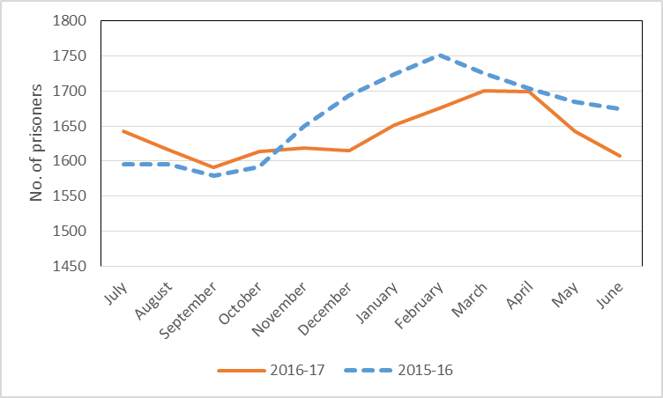

Figure 10 Monthly daily average of sentenced and unsentenced adults, 2016-17

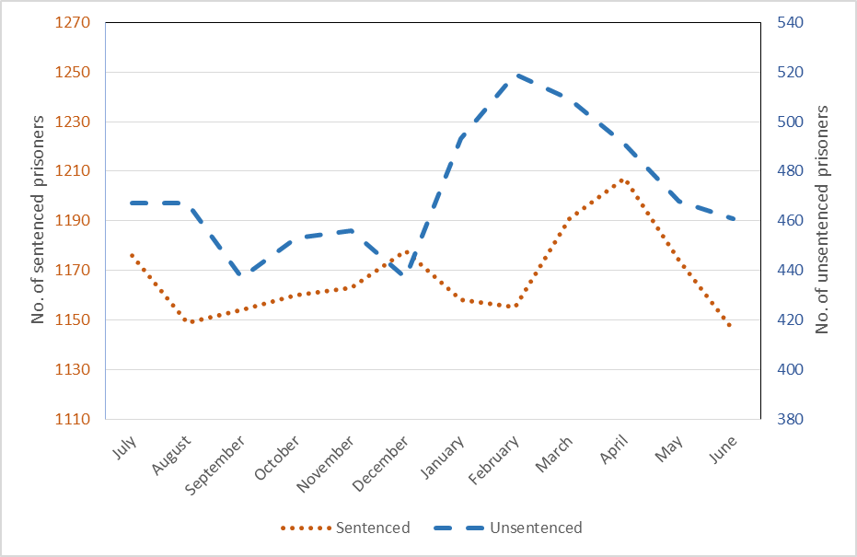

Table 16 Adult releases by correctional institution, release reason and Aboriginal status.

|  |  |  |  |  |  |  |  |  |  |  |  |  |  |  |  |  |
| --- | --- | --- | --- | --- | --- | --- | --- | --- | --- | --- | --- | --- | --- | --- | --- | --- |
| **Release Reason** | **Alice Springs Correctional Centre** | |  | **Darwin Correctional Centre** | |  | **Barkly Work Camp** | |  | **Datjala Work Camp** | |  | **All Prisons** | | **Total** | |
| **Aboriginal** | **Non-Aboriginal** |  | **Aboriginal** | **Non-Aboriginal** |  | **Aboriginal** | **Non-Aboriginal** |  | **Aboriginal** | **Non-Aboriginal** |  | **Aboriginal** | **Non-Aboriginal** | **2016-17** | 2015-16 |
| Appeal Upheld | 1 | 0 |  | 0 | 0 |  | 0 | 0 |  | 0 | 0 |  | 1 | 0 | **1** | 5 |
| Death | 1 | 0 |  | 2 | 0 |  | 0 | 0 |  | 0 | 0 |  | 3 | 0 | **3** | 4 |
| Deportation | 0 | 1 |  | 0 | 1 |  | 0 | 0 |  | 0 | 0 |  | 0 | 2 | **2** | 4 |
| Expiry Of Sentence (Full Term) | 834 | 27 |  | 698 | 96 |  | 96 | 1 |  | 28 | 0 |  | 1656 | 124 | **1780** | 1826 |
| Extradition | 13 | 3 |  | 1 | 10 |  | 0 | 0 |  | 0 | 0 |  | 14 | 13 | **27** | 25 |
| Home Detention | 0 | 1 |  | 1 | 6 |  | 0 | 0 |  | 0 | 0 |  | 1 | 7 | **8** | 9 |
| Interstate Transfer | 1 | 0 |  | 0 | 2 |  | 0 | 0 |  | 0 | 0 |  | 1 | 2 | **3** | 2 |
| Other Discharge From Custody | 316 | 35 |  | 628 | 168 |  | 2 | 0 |  | 0 | 0 |  | 946 | 203 | **1149** | 1240 |
| Parole | 34 | 2 |  | 49 | 23 |  | 3 | 0 |  | 1 | 1 |  | 87 | 26 | **113** | 132 |
| Supervised Bond | 412 | 61 |  | 548 | 154 |  | 9 | 1 |  | 4 | 1 |  | 973 | 217 | **1190** | 879 |
| Under Appeal | 1 | 0 |  | 0 | 0 |  | 0 | 0 |  | 0 | 0 |  | 1 | 0 | **1** | 4 |
| Unknown - Discharge From Custody | 5 | 3 |  | 9 | 0 |  | 0 | 0 |  | 0 | 0 |  | 14 | 3 | **17** | 69 |
| Unknown – Transfer To Community Supervision | 3 | 1 |  | 3 | 1 |  | 0 | 0 |  | 0 | 0 |  | 6 | 2 | **8** | 0 |
|  |  |  |  |  |  |  |  |  |  |  |  |  |  |  |  |  |
| **Total 2016-17** | **1621** | **134** |  | **1939** | **461** |  | **110** | **2** |  | **33** | **2** |  | **3703** | **599** | **4302** |  |
| Total 2015-16 | 1539 | 149 |  | 1933 | 428 |  | 123 | 1 |  | 24 | 2 |  | 3619 | 580 |  | 4199 |
| **Prison Total 2016-17** | **1755** | |  | **2400** | |  | **112** | |  | **35** | |  | **4302** | |  |  |
| Prison Total 2015-16 | 1688 | |  | 2361 | |  | 124 | |  | 26 | |  | 4199 | |  |  |

***Other******Discharge From Custody*** *– These are predominantly prisoners released from court, ie bailed or released following finalisation of charges. Also includes releases on non-supervised bonds and community work orders.*

* The total number of prisoners released increased by 2% compared with the previous year.
* Prisoners released for ‘expiry of sentence (full term)’ decreased by 3% compared with the previous year.
* Prisoners released to ‘supervised bond’ increased by 35% compared with the previous year.

.

Table 17 Distinct adults received by correctional institution, age, sex and Aboriginal status.

|  |  |  |  |  |  |  |  |  |  |
| --- | --- | --- | --- | --- | --- | --- | --- | --- | --- |
| **Age Group** | **Sex** | **Alice Springs Correctional Centre** | |  | **Darwin Correctional Centre** | |  | **Total** | |
| **Aboriginal** | **Non-Aboriginal** |  | **Aboriginal** | **Non-Aboriginal** |  | **2016-17** | 2015-16 |
| 16 to 17 years | All | 0 | 0 |  | 0 | 0 |  | **0** | 1 |
|  | Male | 0 | 0 |  | 0 | 0 |  | **0** | 0 |
|  |  |  |  |  |  |  |  |  |  |
| 18 to 19 years | All | 71 | 4 |  | 80 | 9 |  | **164** | 192 |
|  | Male | 67 | 4 |  | 71 | 6 |  | **148** | 172 |
|  |  |  |  |  |  |  |  |  |  |
| 20 to 24 years | All | 216 | 6 |  | 246 | 39 |  | **507** | 565 |
|  | Male | 186 | 5 |  | 225 | 33 |  | **449** | 509 |
|  |  |  |  |  |  |  |  |  |  |
| 25 to 29 years | All | 259 | 22 |  | 317 | 73 |  | **671** | 692 |
|  | Male | 218 | 20 |  | 273 | 62 |  | **573** | 606 |
|  |  |  |  |  |  |  |  |  |  |
| 30 to 34 years | All | 242 | 23 |  | 246 | 70 |  | **581** | 593 |
|  | Male | 192 | 21 |  | 212 | 62 |  | **487** | 506 |
|  |  |  |  |  |  |  |  |  |  |
| 35 to 39 years | All | 201 | 13 |  | 201 | 53 |  | **468** | 446 |
|  | Male | 170 | 13 |  | 173 | 47 |  | **403** | 379 |
|  |  |  |  |  |  |  |  |  |  |
| 40 to 44 years | All | 149 | 14 |  | 156 | 46 |  | **365** | 348 |
|  | Male | 130 | 14 |  | 136 | 36 |  | **316** | 290 |
|  |  |  |  |  |  |  |  |  |  |
| 45 to 49 years | All | 105 | 8 |  | 104 | 32 |  | **249** | 265 |
|  | Male | 87 | 6 |  | 90 | 28 |  | **211** | 224 |
|  |  |  |  |  |  |  |  |  |  |
| 50 to 59 years | All | 75 | 12 |  | 79 | 34 |  | **200** | 189 |
|  | Male | 67 | 9 |  | 67 | 30 |  | **173** | 163 |
|  |  |  |  |  |  |  |  |  |  |
| 60 years and older | All | 10 | 7 |  | 8 | 16 |  | **41** | 36 |
|  | Male | 9 | 7 |  | 8 | 16 |  | **40** | 32 |
|  |  |  |  |  |  |  |  |  |  |
| **Average age** | **All** | **33** | **37** |  | **33** | **36** |  | **33** | 33 |
|  |  |  |  |  |  |  |  |  |  |
| **Total 2016-17** | **All** | **1328** | **109** |  | **1437** | **372** |  | **3246** |  |
|  | **Male** | **1126** | **99** |  | **1255** | **320** |  | **2800** |  |
|  | **Female** | **202** | **10** |  | **182** | **52** |  | **446** |  |
| Total 2015-16 | All | 1401 | 115 |  | 1445 | 366 |  |  | 3327 |
|  | Male | 1187 | 105 |  | 1278 | 311 |  |  | 2881 |
|  | Female | 214 | 10 |  | 167 | 55 |  |  | 446 |

***Note:*** *The age group and correctional institution is for the first reception for a distinct person.*

*Youths aged 15 to 17 years can be accommodated in adult correctional institutions.*

* The average age of distinct Aboriginal adults received into custody in 2016-17 was 33 years and for distinct non-Aboriginal adults it was 36 years.
* The average age of distinct non-Aboriginal adults held in Alice Springs Correctional Centre increased from 34 in 2015-16 to 37 in 2016-17.
* During 2016-17, there were 41 distinct persons aged 60 years or older received into custody, which represented 1% of distinct persons received. The eldest person received was 80 years of age.

Table 18 Distinct adults received by correctional institution, place of origin and Aboriginal status.



***Place of origin*** *– Self reported location of origin, as recorded in IJIS and aggregated into Police Districts.*

***Note:*** *The correctional institution is for the first reception for a distinct person.*

* Interstate prisoners decreased by 5% or 21 distinct prisoners from the previous year. They comprised 12% (400) of distinct prisoners received into an adult correctional centre during the year and 48% of total distinct non-Aboriginal prisoners.
* The number of prisoners from overseas locations increased by 19% or 19 distinct prisoners from the previous year.

Table 19 Summary of adult sentenced episode commencements by aggregate sentence and offence, 2016-17

**Aggregate sentence** – Is determined as the period between the most recent full-time discharge date (as at   
30 June 2017) and the date of reception for the episode.

**Most serious offence** – As recorded from information derived from IOMS and IJIS.

* There were 2,594 sentenced episode commencements of 2,163 distinct persons during 2016-17, which is almost 1% more than in 2015-16. This includes 265 people who were on remand on 30 June 2016 who became sentenced within the same episode during the following 12 months.
* These sentenced episode commencements relate to 2,163 distinct persons.
* ‘Acts intended to cause injury’ was the most common offence type for sentences commencing in   
  2016-17 comprising 42% of the commencements. This was followed by ‘Offences against justice procedures, government security and government operations’ (27%) and ‘Traffic and vehicle regulatory offences’ (9%).
* ‘Murder’ and ‘Attempted murder’ overall received the longest aggregate sentences of life and more than 16 years, respectively.  They were followed by ‘Manslaughter and driving causing death’ and ‘Sexual assault and related offences’ which had average aggregate sentences of 7.5 years and  4.7 years respectively which experienced a reduction (16% and 6% respectively) for of both of these offence groups compared with 2015-16.
* Four people commenced a life sentence for murder during 2016-17.
* 66% of the sentenced episode commencements had an aggregate sentence of less than 6 months. The average aggregate sentence for sentenced episode commencements was 262 days, which is 22 days less than for the previous year.

Table 20 Adult sentenced episode commencements by aggregate sentence, Aboriginal status and offence, 2016-17



* Aboriginal people represented 90% of the sentenced episode commencements. The average aggregate sentence length for Aboriginal prisoners was 237 days, 249 days less than that for Non-Aboriginal prisoners.

Table 21 Adult sentenced episodes held by aggregate sentence, offence and Aboriginal status,

2016-17



* There were 3,792 sentenced episodes in 2016-17 which commenced a sentenced status prior to or during 2016-17; 88% of these episodes related to Aboriginal prisoners.
* The average aggregate sentence for those held during 2016-17 was 507 days and the median was 180 days.
* During 2016-17, there were 68 episodes in which the aggregate sentence for the prisoner was either a life or indefinite sentence; **murder** was the most serious offence for 45 of these episodes.

Table 22 Adult sentenced episodes commenced by aggregate sentence, offence and gender,

2016-17



**Aggregate sentence** – Is determined as the period between the most recent full-time discharge date (as at 30 June 2017) and the **date of reception for the episode.**

**Most serious offence** – As recorded from information derived from IOMS and IJIS.

* In 2016-17, there were 273 sentence commencements for adult females, 4% more than the previous year. Adult female commencements represented 11% of all sentence commencements for all adults during this period.
* The average aggregate sentence length for females was 216 days which is 46 days less than the average for all adults.
* 'Acts intended to cause injury' was the most common offence for females who commenced a sentence in 2016-17 (36% of commencements), followed by ‘Offences against justice procedures, government security and government operations’ (30%) and ‘Traffic and vehicle regulatory offences’ (13%).

Figure 11 Distribution of aggregate sentence commencements for adults according to selected offences and age* group, 2016-17

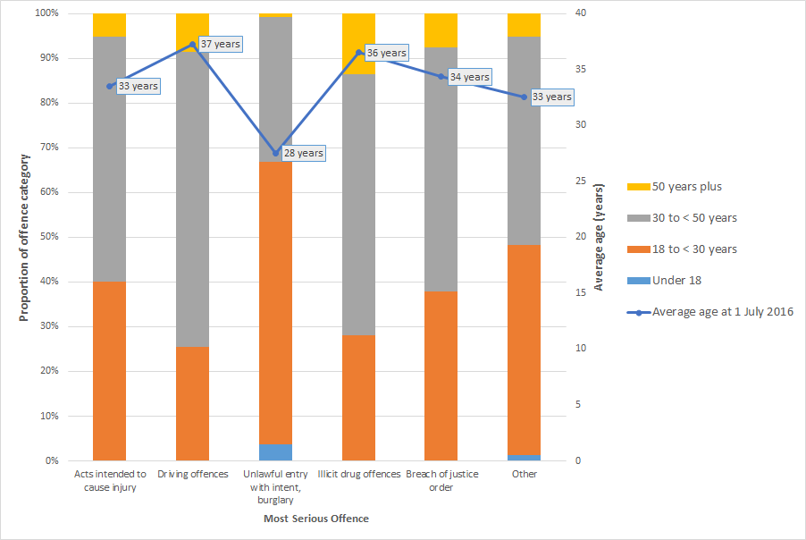

*Ages are calculated as at 1 July 2016, hence some individuals were less than 18 years (ie. less than the age of an adult).

Community Corrections Caseload as at 30 June 2017

Table 23 Community Corrections adult caseload by office, Aboriginal status and order.



***Note:***

*Adult status is based on age at commencement of order.*

*Figures are distinct by order thus the total figure does not represent distinct clients, as a client may have different oders active simultaneously.*

*Active/draft orders counted only, i.e. no orders in breach included.*

*Please note that figures for 2016 have been amended to include bail supervision orders.*

* There was a 13% increase in the adult caseload as at 30 June 2017 compared with the same time the previous year.
* Aboriginal persons represented 76% of the adult caseload as at 30 June 2017.
* There was a 33% increase in orders for the Alice Springs office and a 32% increase in orders for the Katherine office.
* Bail supervision orders increased by 93% while community custody orders increased by 85% compared with the same time the previous year.

Table 24 Community Corrections youth caseload by office, Aboriginal status and order.



***Note:***

*Youth status is based on age at commencement of order.*

*Figures are distinct by order thus the total figure does not represent distinct clients, as a client may have different orders active simultaneously.*

*Active/draft orders counted only ie no orders in breach included.*

*Please note that figures for 2016 have been amended to include bail supervision orders.*

* There was a 6% decrease in the youth caseload as at 30 June 2017 compared with the same time the previous year.
* Aboriginal persons represented 96% of the youth caseload as at 30 June 2017.
* Youth Probation orders represented the most common type of order.
* There was a 33% decrease in orders for the Groote Eylandt office.
* Compared with the previous year, community work orders decreased by 47% and bail supervision increased by 283%.

Figure 12 Northern Territory Community Corrections Caseload as at 30 June 2017.

Community Corrections Turnover During 2016-17

Table 25 Community corrections order completions.

|  |  |  |  |  |  |  |  |
| --- | --- | --- | --- | --- | --- | --- | --- |
| **Order** | **Completions** | | | |  | **Success Rate** | |
| **Successful** | **Unsuccessful** | **Other** | **Total** |  | **2016-17** | 2015-16 |
| Community work orders |  |  |  |  |  |  |  |
| Adult | 252 | 85 | 1 | **338** |  | **75%** | 74% |
| Youth | 65 | 43 | 1 | **109** |  | **60%** | 56% |
| Home detention/Youth alternative detention |  |  |  |  |  |  |  |
| Adult | 20 | 2 | 0 | **22** |  | **91%** | 86% |
| Youth | 4 | 6 | 0 | **10** |  | **40%** | 43% |
| Parole |  |  |  |  |  |  |  |
| Adult | 55 | 49 | 7 | **111** |  | **53%** | 57% |
| Youth | 1 | 1 | 0 | **2** |  | **50%** | 75% |
| Probation |  |  |  |  |  |  |  |
| Adult | 569 | 222 | 12 | **803** |  | **72%** | 75% |
| Youth | 70 | 44 | 1 | **115** |  | **61%** | 47% |
| Community custody order |  |  |  |  |  |  |  |
| Adult | 63 | 26 | 0 | **89** |  | **71%** | 77% |
| Community based order |  |  |  |  |  |  |  |
| Adult | 2 | 0 | 0 | **2** |  | **100%** | 50% |
|  |  |  |  |  |  |  |  |
| **Total 2016-17** | **1101** | **478** | **22** | **1601** |  | **70%** |  |
| ***Adult*** | **961** | **384** | **20** | **1365** |  | ***71%*** |  |
| ***Youth*** | **140** | **94** | **2** | **236** |  | ***60%*** |  |
|  |  |  |  |  |  |  |  |
| Total 2015-16 | 1098 | 478 | 33 | 1609 |  |  | 70% |
|  |  |  |  |  |  |  |  |

***Other*** *– Includes interstate transfers, withdrawal of order and deaths.*

***Success rate*** *– Is expressed as a proportion of successful and unsuccessful completions only.*

***na –*** *not applicable*

* The success rate for the completion of youth probation increased noticeably from 47% to 61%.

Table 26 Community corrections order commencements by Aboriginal status and gender.

|  |  |  |  |  |  |  |  |  |  |  |  |
| --- | --- | --- | --- | --- | --- | --- | --- | --- | --- | --- | --- |
| **Order** | **Aboriginal** | |  | **Non-Aboriginal** | |  | **All** | |  | **Total** | |
| **Female** | **Male** |  | **Female** | **Male** |  | **Female** | **Male** |  | **2016-17** | 2015-16 |
| Community work order |  |  |  |  |  |  |  |  |  |  |  |
| Adult | 64 | 236 |  | 13 | 42 |  | 77 | 278 |  | **355** | 393 |
| Youth | 19 | 69 |  | 1 | 1 |  | 20 | 70 |  | **90** | 117 |
| Home detention/Youth alternative detention |  |  |  |  |  |  |  |  |  |  |  |
| Adult | 4 | 5 |  | 4 | 10 |  | 8 | 15 |  | **23** | 28 |
| Youth | 1 | 6 |  | 0 | 2 |  | 1 | 8 |  | **9** | 6 |
| Parole |  |  |  |  |  |  |  |  |  |  |  |
| Adult | 14 | 74 |  | 2 | 24 |  | 16 | 98 |  | **114** | 132 |
| Youth |  | 1 |  |  |  |  | 0 | 1 |  | **1** | 2 |
| Probation |  |  |  |  |  |  |  |  |  |  |  |
| Adult | 156 | 698 |  | 25 | 153 |  | 181 | 851 |  | **1032** | 950 |
| Youth | 33 | 115 |  | 1 | 6 |  | 34 | 121 |  | **155** | 166 |
| Community custody order |  |  |  |  |  |  |  |  |  |  |  |
| Adult | 24 | 72 |  | 2 | 5 |  | 26 | 77 |  | **103** | 79 |
| Community based order |  |  |  |  |  |  |  |  |  |  |  |
| Adult | 0 | 2 |  | 1 | 0 |  | 1 | 2 |  | **3** | 0 |
| Final supervision order |  |  |  |  |  |  |  |  |  |  |  |
| Adult | 0 | 1 |  | 0 | 0 |  | 0 | 1 |  | **1** | 1 |
|  |  |  |  |  |  |  |  |  |  |  |  |
| **Total 2016-17** | **315** | **1279** |  | **49** | **243** |  | **364** | **1522** |  | **1886** |  |
| ***Adult*** | ***262*** | ***1088*** |  | ***47*** | ***234*** |  | ***309*** | ***1322*** |  | ***1631*** |  |
| ***Youth*** | ***53*** | ***191*** |  | ***2*** | ***9*** |  | ***55*** | ***200*** |  | ***255*** |  |
|  |  |  |  |  |  |  |  |  |  |  |  |
| Total 2015-16 | 282 | 1294 |  | 56 | 242 |  | 338 | 1536 |  |  | 1874 |

* There was a 1% increase in the number of community corrections commencements in   
  2016-17 compared with the previous year.
* The number of adults commencing parole decreased by 14% in 2016-17 compared with 2015-16, whilst the number of commencements of community custody orders increased by 30%.

Table 27 Distinct persons commencing a community corrections order by Aboriginal status and gender.

|  |  |  |  |  |  |  |  |  |  |  |  |
| --- | --- | --- | --- | --- | --- | --- | --- | --- | --- | --- | --- |
|  | **Aboriginal** | |  | **Non-Aboriginal** | |  | **All** | |  | **Total** | |
| **Female** | **Male** |  | **Female** | **Male** |  | **Female** | **Male** |  | **2016-17** | 2015-16 |
| Distinct Adults | 246 | 1023 |  | 44 | 228 |  | 290 | 1251 |  | **1541** | 1479 |
| Distinct Youths | 29 | 133 |  | 2 | 7 |  | 31 | 140 |  | **171** | 191 |
|  |  |  |  |  |  |  |  |  |  |  |  |
| **Distinct Persons 2016-17** | **275** | **1153** |  | **46** | **235** |  | **321** | **1388** |  | **1709** |  |
| Distinct Persons 2015-16 | 256 | 1139 |  | 49 | 224 |  | 305 | 1363 |  |  | 1668 |

***Note:*** *The sum of distinct adults and youths may differ to the total distinct persons, as a person could appear as both an adult and youth in the same year.*

* There was a 2% increase in the number of distinct persons commencing a community corrections order in 2016-17 compared with the previous year.
* Females represented 19% of the distinct persons who commenced a community corrections order in 2016-17.

APPENDIX 1

Offence Classifications

The offences used in this report are based on the Australian and New Zealand Standard Offence Classification. Offences are grouped into Division and Subdivision level and are as follows:

**Offences Against the person**

**Homicide and related offences**

Murder

Attempted murder

Manslaughter and driving causing death

**Acts intended to cause injury**

Assault

Other acts intended to cause injury

**Sexual assault and related offences**

Sexual assault

Non-assaultive sexual offences

**Dangerous or negligent acts endangering persons**

Dangerous or negligent operations of a vehicle  
Other dangerous or negligent acts endangering persons

**Abduction, harassment and other offences against the person**

Abduction and kidnapping  
Deprivation of liberty/False imprisonment

Harassment and threatening behaviour

**Robbery, extortion and related offences**

Robbery  
Blackmail and extortion

**Property Offences**

**Unlawful entry with intent/Burglary, break and enter**

Unlawful entry with intent/Burglary, break and enter

**Theft and related offences**

Motor vehicle theft and related offences  
Theft (except motor vehicles)   
Receive or handle proceeds of crime  
Illegal use of property (except motor vehicles)

**Fraud, deception and related offences**

Obtain benefit by deception

Forgery and counterfeiting  
Deceptive business/government practices  
Other fraud and deception offences

**Property damage and environmental pollution**

Property damage  
Environmental pollution

**Other Offences**

**Illicit drug offences**

Import or export illicit drugs  
Deal or traffic in illicit drugs  
Manufacture or cultivate illicit drugs  
Possess and/or use illicit drugs  
Other illicit drug offences

**Prohibited and regulated weapons and explosive offences**

Prohibited weapons/Explosives offences  
Regulated weapons/Explosives offences

**Public order offences**

Disorderly conduct  
Regulated public order offences

Offensive conduct

**Traffic and vehicle regulatory offences**

Driver licence offences  
Vehicle registration and roadworthiness offences  
Regulatory driving offences (eg Exceeding the prescribed content of alcohol, Exceed legal speed limit)   
Pedestrian offences

**Offences against justice procedures, government security and government operations**

Breach of custodial order offences

Breach of community-based orders

Breach of violence and non-violence ordersOffences against government operations

Offences against government security

Other offences against justice procedures

**Miscellaneous offences**

Defamation, libel and privacy offences

Public health and safety offences

Commercial/industry/financial regulation

Other miscellaneous offences

1. *Derived from the Australian Bureau of Statistics publication (3101.0) – Australian Demographic Statistics, June 2017.* 
2. *Derived from the Australian Bureau of Statistics publication (4512.0) – Corrective Services Australia, June quarter 2017.*
3. *The NT and national non‑Aboriginal adult population estimates for 2016-17 were derived from rates used in ABS (4512.0) Corrective Services Australia – June Quarter 2017.*
4. *The most serious offence for the custody episode as recorded in IOMS.*
5. *Figures for 2016-17 - Estimates based on ABS Corrective Services Australia – June Quarter 2017.*
6. *Most serious offence as recorded in IOMS.*